FEDERAL DEMOCRATIC REPUBLIC OF ETHIOPIA MINISTRY OF EDUCATION

T: +251 11 155 3133

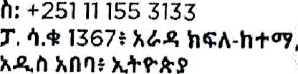P.O. BOX J367, ARADA SUB•CITY, ADDIS ABABA, ETHIOPIA

www.moegovot

wwwCaceDookcomld emoe

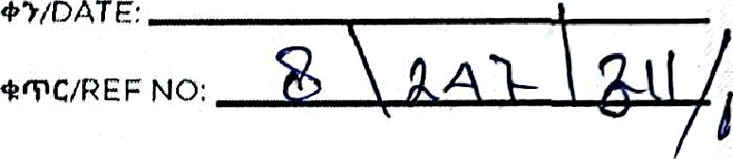@' @fdemoe Info moe ov







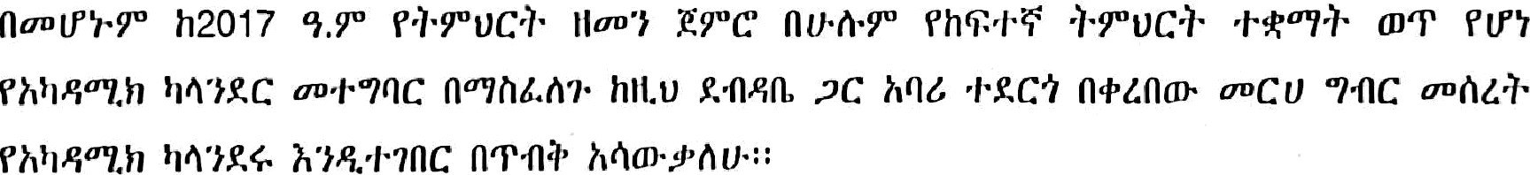

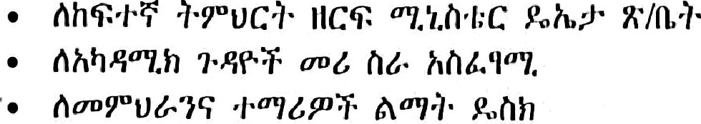

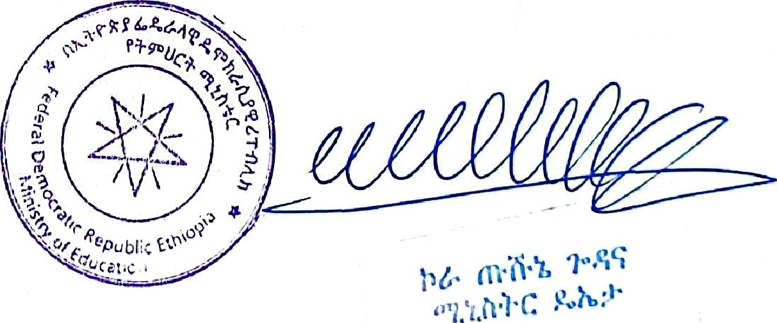



 

The 2024/25 (2017 E.C) Acatleniic Calendar (draft for comments)

|  |  |  |  |  |  |  |  |  |  |
| --- | --- | --- | --- | --- | --- | --- | --- | --- | --- |
|  |  |  |  |  |  |  |  |  |  |
| SEP 17 and 1 8, 2024 ( ^'flllZ.Y°  7 h T 8/20 i 7 ’I.f°) | | First year undergraduate students reporting date | | | | | | | |
| Sep 19-20, 2024 ( •oliz.w  9-10/2017 1.W) | | Orientation for first year undergraduate students | | | | | | | |
| Life skills training for first year undergraduate students. | | | | | | | |
| Registration for all undergraduate and postgraduate regular and non-regular  students | | | | | | | |
| Sep 23 (•••,At IiZ) 13/2017 | | Late registration with Penalty for undergraduate and postgraduate regular  students | | | | | | | |
| First Semester class begins for all undergraduate and postgraduate students. | | | | | | | |
| Jan 10, 2025 (+C 2/204 7 | | First Semester class ends for all undergraduate and postgraduate students. | | | | | | | |
| Jan 13 to Jan 21/2025  (vP• 5-13/2017 '1.W) | | First semester exam period | | | | | | | |
| Sept 16/2024 (°°f1h8f  6/20 7), Sept 27, 2024  ( •Ah4y° 17/2017 1.W),  January 7, 2025 (fUt/i 29  2017) and Jan 19, 2025  *[*'T'*T* 11 2017 'T.@) 13/2017 | | PUBLIC HOLIDAYS IN SEMESTER 1 2017 E.C | | | | | | | |
| Jan 22 -31, 2025 *(WC* 14-  23/2017 9. ) | | NGAT and Mid-year exit exam period | | | | | | | |
| INTER-SEMESTER BREAK | | | | | | | |
| Feb 3 and 4, 2025 (+c  26-27/2017 9.U) | | Registration for all UG and PG students for 2nd-semester | | | | | | | |
| Feb 5,2025 *)rC* 28/2017 | | Late registration for all UG and PG students | | | | | | | |
| Second Semester class begins for all undergraduate & postgraduate students. | | | | | | | |
| Feb 5-6,2025 (vC 28-  29/2017 ’f.T') | | Employability and job creation training for graduating class | | | | | | | |
| May 27, 2025 (-i'n I  19/2017 1.y") | | Second Semester class ends for all undergraduate & postgradiiate siiidents’ | | | | | | | |
| day 28 to June 5, 2025  (°/“}{1•}• 20-28/2017 1. ) | | Second Semester exam period | | | | | | | |
| June 9-17 2025 (dk 2-  i 0/2017 ’f. ) | | Exit exam for undergraduate graduating class students | | | | | | | |
| June 19-22, 2025 (Ak 12-  15/2017 ’t. ) | | Graduation week | | | | | | | |
| June 25 to July 4, 2025  (01 18-27/2017 1. ) | | Grade 12 Exam Period | | | | | | | |

1

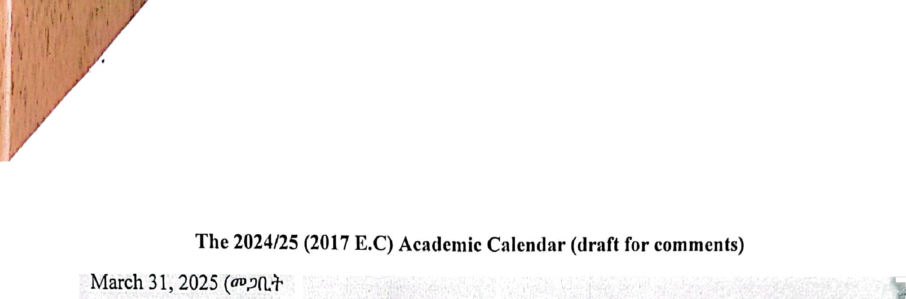

 

|  |  |
| --- | --- |
| 22/2017 1.P’), Aprit 18,  2025 (wJ’1lJ’ 10/2017) and  May 1, 2025 ('•tJsu•  23/2017 1.W) and May  5/2025 ("7.f1IJ' 27/2017 | ”  PUBLIC HOLIDAYS IN SEMESTER II 2017 E.C |
| July 8-9, 2025 {.i›ne 1‘  Z/2017 1.P°) | Registration period for summer & extension students |
| July 10, 2024 .i»a 3/2047 9.Z°) | Late registration with penalty for summer and extension students |
| Class begins for summer & extension students |
| August 5-6, 2025 30  ( /iy°A 29-30/2017 ’ł. ) | NGAT exam for PG Applicants |
| August 29 to Sept 8,  2025 (Y1ń. 23 hAt› 4ę. g  3/2017 'ł.y°) | *Final exam period for* summer *and extension program studenta* |
| Sept 10, 2025 (41"Y  5/2017 'ł. ) | Last day of submitting FIRST summer students result |

2