Chapter 4
Financial Analysis of Agricultural Projects
- Objectives of Financial Analysis
1. Assessment of financial impact
2. Judgment of efficient resource use
3. Assessment of incentives
4. Provision of sound financial plan
4.1. Pricing Project Costs and Benefits
- Once costs and benefits have been identified if they are to be compared they must be valued.
- Since the only practical way to compare differing goods and services directly is to give each a money value,
- Therefore, we must find the proper prices for the costs and benefits in our analysis.
Finding Market Prices
- Project analysis characteristically are built first by identifying the technical inputs and output for a proposed investment, then by valuing the inputs and outputs at market prices to construct the financial accounts, and finally by adjusting the financial prices so they better reflect economic values.
- Thus, the first step in valuing costs and benefits is finding the market prices for the inputs and outputs.
- The project analyst will have to consult many sources such as merchants, consumers, experts, published statistical bulletins, etc.
Point of first sale and farm-gate price
- In project analysis, a good rule for determining a market price for agricultural commodities produced in the project is to seek the price at the “point of first sale”.
- The increased value added of the product as it goes to higher markets in the channel arises as a payment for marketing services.
- Thus, if the project includes such marketing services in its design, we can take these higher prices.
- Even in this case, the analyst must make the project as small as possible and try to analyze the marketing service component independently of the production component.
- If the product is sold only in central markets, no local market, then the analyst must find out the value of marketing service to arrive at price at project site.
- Prices for some products like agricultural products generally are subjected to substantial seasonal fluctuation.
- Therefore, some decision must be made about the price in the seasonal cycle to choose the price to be used for the analysis.
- A good starting point is the farm-gate price at the peak of the harvest season.
- This is probably close to the lowest price in the cycle.
- The reason is that the rise in price is due to marketing services.
Predicting Future Prices
- Since project analysis is about judging future returns from future investment, we have to judge what the future prices of inputs and outputs may be.
- The best starting point is to see the trend of these prices over the past few years.
- Having this data, the project analyst can forecast the price with certain degree of precision.
- Moreover, we have to keep in mind that, as projects involve distant future, the prediction power of the model will decline as we go far from the present.
Change in prices
- Change in prices could be general change in price or change in relative prices of goods
- Change in relative price: If relative price of inputs or outputs are variable over time, i.e.,
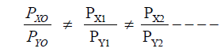
- These changes in relative price of items imply a change in marginal productivity of inputs in production or a change in marginal satisfaction (MU) in consumption.
- Thus, changes in relative prices have a real effect on the project objective
- It must be reflected in project accounts in the years when such changes are expected.
- This can be judged from past trend.
- For instance, the price of agricultural products to price of inputs (manufactured) may rise over time. This would have a real effect on the net benefit of the firm.

Inflation: an increase in general prices of goods
- Inflation is common for every country although the magnitude may vary between countries.
- However, the approach most often taken is to work the project analysis in constant price.
- It is assumed that inflation will affect most prices to the same extent so that prices retain their same general relations.
- The analyst then need only adjust future price estimates for anticipated relative changes, not for any change in the general price level.
- As indicated earlier, financial analysis will be made based on market price.
- The project may use imported inputs and export its output to foreign markets.
- If there are domestic markets for these inputs and outputs, and if the firm is free to sell or buy at the domestic or world market, we take the domestic price with appropriate adjustment to reflect the price at the project site.
- If, on the other hand, commodities of the project are produced only for foreign market or if the domestic demand cannot absorb the firm’s output, we will take export-parity and import parity prices ever in financial analysis.
4.2. Time value of money
- Present values are better than the same values in the future and earlier returns are better than later.
- This shows that money has time value. Thus, to include the time dimension in our project evaluation, we have to use discounting methods.
- Compounding: Interest rates reflect time values as defined by the financial markets. To determine future value of money, therefore, a compound interest rate is applied and this process is generally referred to as compounding.
- Future values (FV) are obtained by the formula:
FV = PV (1 + r)t . The expression: (1 + r)t is a compounding factor.
- Discounting: Discounting is the opposite of compounding and the process involves finding the present value or worth of a future amount.
- Discounting is essentially a technique that ‘reduces’ future benefits and costs to their ‘present worth’. The rate used for discounting is called discount rate. The expression: 1/ (1 + r)t is a discount factor. the formula for present value is expressed as:
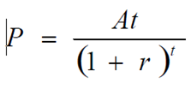
- Suppose a bank lends 1567.05 Birr for a project at 5% interest rate. The project owner is supposed to repay the principal & interest rate after 5 years. How much the owner will have to pay at the end of 5 years.
At -= P(1 + r) t
At = total amount after t years
r = interest rate
t = time
P=Principal
A5 = 1567.05 (1 + 0.05)5
= 2000 Birr
- Suppose again a project is expected to obtain 2000 Birr after 5 years. Value of this money today can be calculated as:
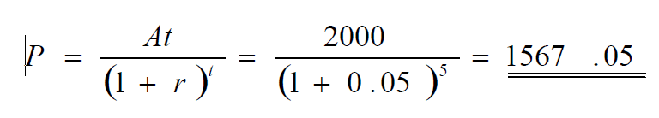
- The difference between this & the previous is only the viewpoint.
- The interest rate used for compounding assumes a viewpoint from here to the future, whereas discounting looks back ward form the future to the present.
4.3. MEASURES OF PROJECT WORTH
- When costs and benefits have been identified, quantified and priced (valued), the analyst is trying to determine which among various projects to accept, which to reject.
- There are two methods for measuring the worthiness of projects:
1. Undiscounted &
2. discounted methods.
- The undiscounted measures of project worth have one serious shortfall: they do not take into account the difference between the value of money today, and the same value in the future.
- By contrast discounted measures of project worth are based on the concept that” to receive some today is better than to receive more tomorrow”
- The arithmetic of these methods, and the way we interpret the measures and their limitations, is exactly the same whether we are using them for financial analysis or for economic analysis.
- There are two critical points important to note
1. There is no one best technique for estimating project worth; each has its own strength & weakness.
2. These financial and economic measures of investment worth are only tools of decision-making. i.e., they are necessary conditions & are not sufficient condition for final decision.
4.3.1. Undiscounted measures of project worth
- The most commonly used non-discounted measures of project worth are
1. Ranking by inspection
2. Payback period
3. Return on investment
Ranking by inspection
- Here by simply looking at the investment costs and the ‘shape’ of the stream for the net value of incremental production that one project should be accepted over another if we must choose.
- The analyst can sometimes simply choose one project among alternative projects by examining the following:
- Total cost of investment and investment period;
- The structure & amount of costs and benefits;
- total amount of the net incremental benefit;
- The lifetime of the project, etc.
- If two projects have the same initial investment, and different lifespan, the same proceeds throughout the period of the short-lived investment, and if the long lived investment to earn income after the end of the short-lived one, then, the long-lived one is more desirable.
- Because all things being equal, the long-lived project continues to earn proceeds while the short lived one has ended.
- Suppose two projects have the same life period, identical initial investment outlay, and the net proceeds throughout the life period is identical; in this case although the total net proceeds is identical, the project that earns more income early than the other is more desirable.
- The problem with Ranking by inspection method is that the selection lacks objectivity.
Payback period
- The payback period is the length of time from the beginning of the project until the sum of net incremental benefits of the project equal to total capital investment.
- It is the length of time that the project requires to recover the investment cost.
- Payback Period is a good measure when the project has problem of liquidity.
- The pay-back period is also a common, rough means of choosing among projects in business enterprise, especially when the choice entails high degree of risk.
- Since risk generally increases with futurity, the criterion seems to favor projects that are prima facie less risky.
- This method has two weaknesses:
1. it fails to consider the time & amount of net benefits after the payback period.
2. it does not adequately take into account the time value of money even in the payable periods.

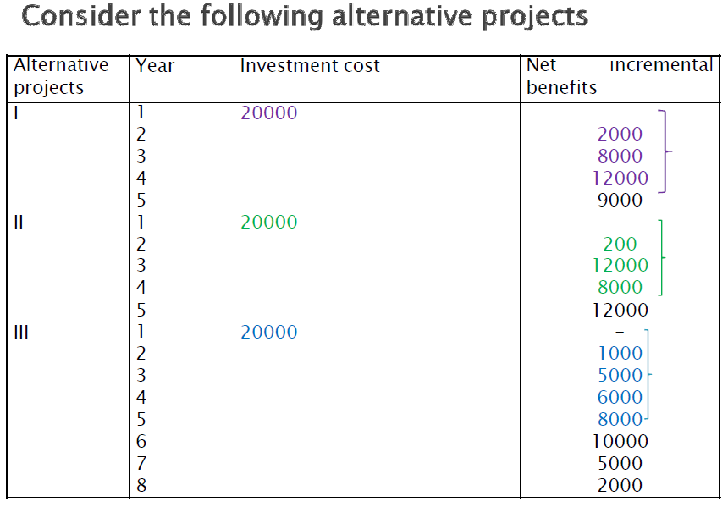
- Project I & II have a payback period of 4 year. But project III has a payback period of 5 years. Thus, based on this criterion, project I & II have equal higher rank than project III.
- Therefore, the method fails to consider the time & amount of net incremental benefit after the payback period- project III.
- In addition, the method results equal rank for both project I and II.
- Yet we know by inspection that we would choose project II over project I because more of the returns to project II are realized earlier.
- Payback Period method is a measure of cash recovery, not profitability.
Return on investment
- Average income on cost is formed by dividing the average income by the cost of investment.
- Average income on cost has the disadvantage of not taking into consideration the timing of the cash flow.
- This measure is useful and commonly used way of assessing the performance of an individual firm.

4.3.2. Discounted measure of project worth
- discounted measures of project worth are based on the concept that” to receive some today is better than to receive more tomorrow”
- Commonly used discounted measures are:
Net Present Value
Internal Rate of Return
Benefit- Cost Ratio
Net Benefit - Investment Ratio
Net present values
- The net present value of an investment proposal is the present value of expected future net cash flows, discounted at the costs of capital, less the initial outlay.
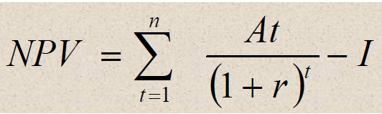
NPV- net present value
At = net cash flow for the year t
r - Cost of capital
n- Life of the project
I- initial outlay
- For financial analysis, the discount rate is usually the marginal cost of money to the firm (project owner).
- This often will be the rate at which the enterprise is able to borrow money.
- All projects that have a positive NPV are accepted and projects that have a negative NPV are rejected.
- In the net present value method, the higher the NPV, the more desirable the project is. That is if we have two mutually exclusive projects, project A and project B - project A may be ranked first in some ranges of discount rates but may turn out to be second in some other ranges.
- However, in ranking mutually exclusive project (if one is chosen, the other cannot be undertaken), ranking based on NPV depends on the discount rate used.
- Discounted measure of project worth based on discounted NPV, though it accounts the time value of money and all flows in the lifetime of the project.
Example 1: Select one of the two following projects, based on highest NPV.
Assume 7% discount rate
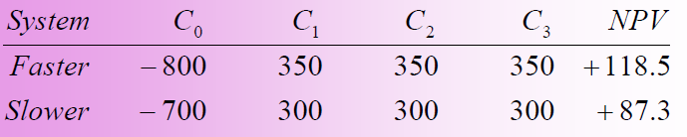
- The project with highest NPV is more desirable. So, faster project is preferred over the slower.
Internal rate of return
- The internal rate of return is the rate of discount at which the total discounted cash proceeds( benefits) expected from the project equals the total discounted cash outlays (costs) required by investment.
- In other words, the IRR is the rate which makes NPV of the project equal to zero

I – investment cost
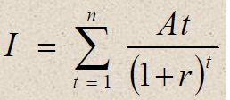
At – Net benefit for year t
r - IRR
n - Life of the project
- Illustration: For a project with investment cost of 1000 and net cash flow of 200,400, 500 and 700 for four consecutive years, IRR is formulated as
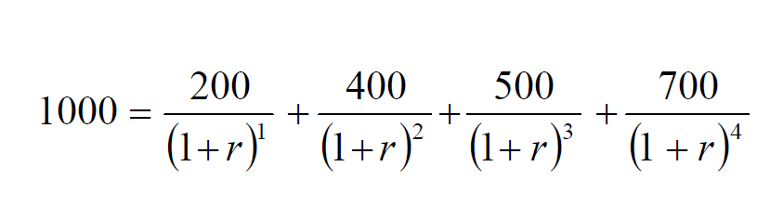
- r can be found through trial & error method.
- When r = 23.068 percent the value in the above equation in the right hand side will be equal to 1000.0087 which is equal to the value in the left hand side.
- The problem with this method is that the value of r (IRR) can only be found by trial and error.
- The procedure to find r can be described as follows:
1. Select an arbitrary value of r;
2. Calculate the value of the right hand side equation with this value of r.
3. If the RHS value is lesser than the value in the left hand, reduce the value of r.
4. If the RHS is greater than the LHS, increase the value of r; continue until this the RHS is very close to the LHS.
5. When the RHS is more or less equal to LHS, it is that value of r, which is the IRR.
- IRR can be interpreted as the highest rate of interest an investor could afford to pay, without loosing money, if all the funds to finance the investment are borrowed, and if the debt service ( loan and accrued interest ) was repaid by use of cash proceeds from the investment.
- When using the IRR, the investment criterion is that the IRR should be greater than the discount rate.
- Generally, for one single project, there is a relationship among the present value, the rate of return, the cost and benefits.
- When the NPV is positive, then IRR is greater than the rate of discount and the discounted benefits are greater than the discounted costs;
- When NPV is equal to zero, then the IRR is equal to the rate of discount and discounted benefits are equal to the discounted costs; and
- When NPV is negative, then the IRR is smaller than the discount rate and the discounted benefits are smaller than the discounted costs.
Benefit-cost ratio
- This is the ratio obtained when the present worth of the benefit stream is divided by the present worth of the cost stream. The mathematical formula is given below.
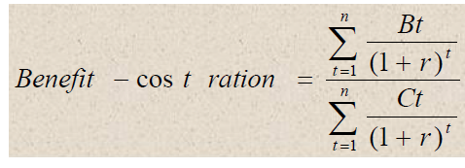
Where
Bt - are the benefits in period t
Ct - are the costs in period t
n - project life
r - discount rate
- The selection criterion for the benefit-cost ratio measure of project worth is that the discounted benefits should exceed discounted costs i.e benefit-cost ratio of greater than 1.
- when the cost and benefit streams are discounted at the discount rate, in the case of mutually exclusive projects, the benefit - cost ratio can lead to an erroneous investment choice.
- This problem can be avoided most easily by using the net present worth criterion for mutually exclusive projects.
Net benefit investment ratio
- This criterion is suitable and convenient for ranking projects especially when sufficient budget is not available to implement all projects that satisfy other criteria.
- That is, two or more projects may all have a positive NPV, IRR that exceeds the discount rate, both financial and economic discount rates, and a benefit-cost ratio of greater than one.
- In this case, ranking could be made using net Benefit - investment ratio.
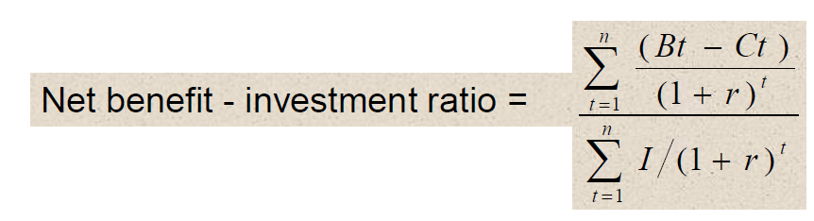
Where ,
Bt -Benefits, Ct - costs, I- investment, r-discount rate, I-investment cost
- It is simply the present value of net benefits divided by the net present worth of the investment.
- The formal selection criterion for the net Benefit - Investment ratio measure of project worth is to accept all projects with a ratio of 1 or greater when they are discounted with appropriate rate - in order, beginning with the largest ratio value and preceding until available investment funds are exhausted.

