Chapter 5
Economic Analysis of Agricultural Projects
- Both economic and financial analysis is to assess profit of the investment. Financial profit – money profit to owner, Social profit - effect of the project on the fundamental objectives of the whole economy.
- Labor wage is financial cost but will be an economic cost only considered its opportunity cost. Some costs may be appear in economic cost may not appear in financial cost and vice versa. Some costs lower in financial may be higher in economic analysis.
- The extent to which economic costs & benefits diverge from their counterpart financial costs and benefits rests on the presence and extent of market imperfections, government interventions of various forms & the fundamental policy objectives.
- It is important to note that judicious use of economic prices (shadow prices, efficiency prices, or accounting prices) is an important means for assessing the economic merits of a project to a country, but is not a substitute for careful analysis of its technical, organizational & managerial, commercial, financial and other relevant aspects to the outcome of a project.
- Once financial price for costs and benefits have been determined and entered in the project accounts, the analyst estimates the economic value of a proposed project to the nation as a whole.
- The financial prices are the starting point for the economic analysis; they are adjusted as needed to reflect the value to the society as whole of both the inputs and outputs of the project.
- When the market price of any good or service is changed to make it more closely represent the opportunity cost (the value of a good or service in its next best alternative) to the society, the new value assigned becomes the “shadow price” or “accounting price” or “economic price” or “efficiency price”.
- Financial appraisal of a project may result a negative NPV but might render positive NPV when it is viewed from society’s point of view - economic analysis. Relying on economic appraisal to justify such a project requires that the analyst pay special attention to the project’s financial variability. The project’s economic variability will be undermined if financial viability is not ensured and expenditures for operations and maintenance will inevitably suffer.
- For projects that are justified because of their positive economic net present value, then, analyst must show explicitly the financial NPV & economic NPV; the amount of the financial short fall and the sources of funds to finance it; and the sustainability of the arrangements.
- Two approaches may be adopted for projects with tangible products depending on whether the aim is:
_ to estimate the effects of the project on the national economy:
_ to assess the project's viability within the international economic environment.
Purpose of Economic Analysis
- Selection of alternatives: The main purpose of project economic analysis is to help design and select projects that contribute most to the welfare of a country.
- Identification of winners and losers: who enjoys the music? Who pays the piper?
A good project contributes to the country’s economic output; hence it has the potential to make everyone better off. Identifying those who will gain, those who will pay and those will lose gives the analyst insight into the incentives that various stake holders have to see that the project is implemented as deigned.
- Environmental impact: A very important difference between society’s point of view and the private point of view concerns costs (or benefits) attributable to the project but not reflected in its cash flows. The effects of the project on the environment, both negative (costs) and positive (benefits), should be taken into account and if possible, quantified and assigned a monetary value. The impact of these costs and benefits on spearfish groups within socially be borne in mind.
- Numéraire : The choice of currency and price level in which to conduct the analysis must be decided first. Financial analysis is usually conducted in the currency of the country undertaking the project and at the prevailing market prices. Economic analysis can be conducted in domestic or foreign currency and at domestic market price or at border price. However, when financial analysis is done in one unit of account and the economic analysis in another, the difference between the financial and the economic values have no meaning. Because comparison of financial and economic analysis conveys much information as gainers and losers, fiscal impact, extent of externalities, extent of market distortions & their policy implications, etc, it is advisable to use same (domestic) currency in both financial & economic analysis.
5.1. Identifying Project Benefits and costs
With and Without Project Scenarios, Constant Prices, and Project Life
There are four broad steps in project economic analysis:
(i) Identify gross project benefits and costs;
(ii) Quantify and value the benefits and costs, initially in market or financial prices;
(iii) Adjust the costs and benefits to reflect their economic values; and
(iv) Compare gross economic benefits with economic costs.
Identification of benefits
- Benefit of a project is a comparison between without project and with project situations.
- The incremental benefit (net benefit with project – net benefit without project) streamed in the flow during project life is defined to be the project benefit.

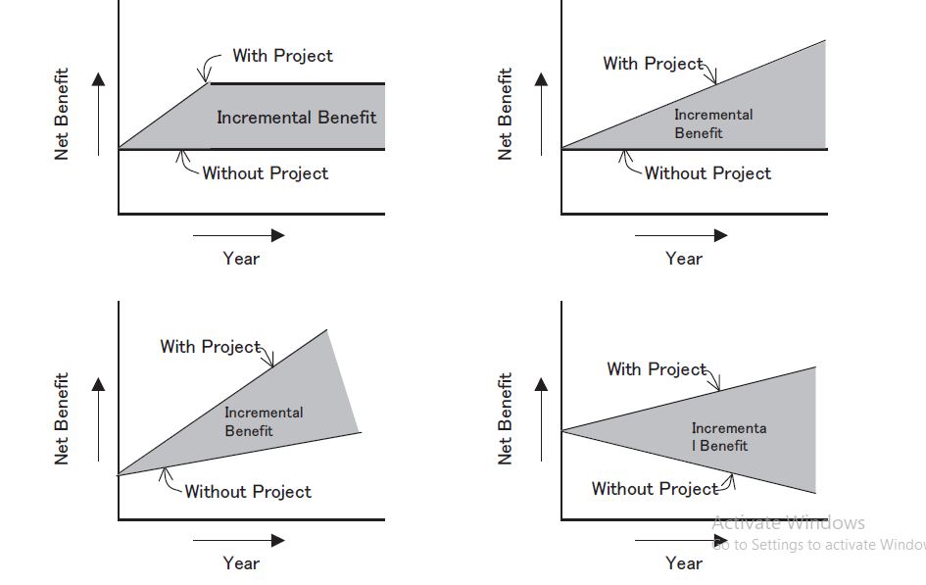
Figure 5.1 Sample of Incremental Benefit
- In terms of valuation in cash, benefits of a project can be categorized as quantifiable or non-quantifiable, and the quantifiable benefits can be categorized into ‘can be valued in cash’ and ‘cannot be valued in cash’, and thirdly the benefits which can be valued in cash are further categorized into the benefit which can be income and cannot be income for the beneficiary.
Eg. Irrigation project
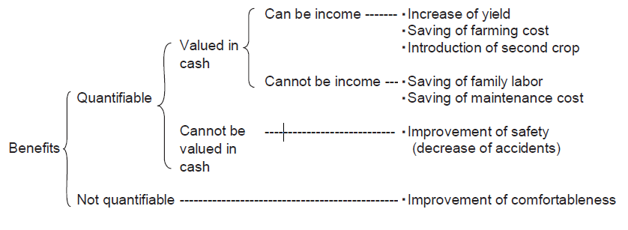
- Economic analysis normally deals with the benefits, which can be valued in cash only. This could sometimes underestimate the value of the project. Therefore, other benefits that cannot be valued in cash should be described and remarked in carrying out the economic analysis.
Identification of Costs
- The incremental and non-incremental distinction is also relevant for inputs and in identifying costs.
- In the incremental case, where supply is expanded to meet project demand, the value of inputs is their marginal cost, since this reflects the resources that must be committed to meet additional project demand.
- In the non-incremental case, where supply is fixed in the short term and project demand draws the input away from other users, the cost of the input will be determined by what other users are willing to pay for it, as this reflects its opportunity cost in terms of additional consumption that the input can produce elsewhere.
- In addition to this distinction, different types of costs need to be distinguished.
- Internal costs
Capital cost and contingencies
- Investment costs will vary between types of project, but normally including land, buildings, machinery and equipment, and various aspects of construction and installation. These costs should be shown in the project statement against the years in which the activity takes place.
- For most projects, they are phased across more than 1 year. Maintenance or replacement expenditure on capital assets during a project’s life should be shown in years during which the expenditure is made.
- Most capital cost estimates contain an element of contingency. Contingency allowances, which are determined by engineering and financial considerations, also have implications for economic appraisal.
- When estimating project costs for financial planning purposes, both physical and price contingencies are included. Since economic returns are measured in constant prices, general price contingencies should be excluded from the economic cost of the project.
- Physical contingencies represent the monetary value of additional real resources that may be required beyond the base cost to complete the project, and should be treated as part of the economic cost. Hence, for project economic analysis, it is appropriate to include the physical contingency allowance, but not the price contingency.
Working capital
- Working capital is the cash, accounts receivables and payables, and physical stocks of goods (both as outputs and inputs) that a project requires for its continued operations.
- Of these items, only physical stocks of goods are treated as a cost in project economic analysis. Accounts receivable is the value of credit advanced to the purchasers of project output and accounts payable is the value of credit received from suppliers of inputs to the project. The difference between the two is the net credit position. The net credit position is treated as a transfer between the project and other enterprises and not a real resource cost in economic terms.
- Similarly, the cash held by the project is not included as an economic cost on the assumption that cash is not in short supply and that the holding of extra cash by one project does not deprive another of cash needed to finance transactions.
Depreciation and interest during construction
- In cases where the financial statements of project executing and/or implementing agencies include provisions for depreciation and amortization, this accounting recognition of depreciation and amortization is not considered in Guidelines for the Economic Analysis of Projects economic analysis to avoid double counting of capital costs.
- This cost already appears in the years in which the capital expenditure is made and replacement expenditure is included as needed during the project’s life. However, it should be noted that the depreciation calculated for tax purposes reduces a project’s profit tax liability and therefore influences the distribution analysis.
- Interest charges accrued during project construction are similarly not included in capital cost in project economic analysis, since the cost of committing capital to the project is covered by discounting and their inclusion would also constitute double counting.
Transfer payments
- Some of the items included in the financial costs of a project are not economic costs, as they do not increase or decrease the availability of real resources to the rest of the economy. These items will, however, affect the distribution of financial costs and benefits between the project entity and other entities, and among project beneficiaries. They are thus referred to as transfer payments, as they transfer command over resources from one party to another without reducing or increasing the amount of resources available for the economy as a whole.
- Taxes, duties, and subsidies are examples of items that, in some circumstances, may be considered transfer payments. They can affect the incomes of the government and of the payers or recipients simultaneously, but in opposite and identical amounts, thus canceling out in an economic analysis. However, there are circumstances when the tax elements should be included in the price of an input or output.
- The economic cost of a non-incremental input diverted to a project from other users should include the tax element, since the tax paid by other users is part of their willingness to pay.
- Similarly, the economic value of incremental outputs will include any tax element imposed on the output (such as value-added tax), which is included in the market price and is therefore part of consumers’ willingness to pay.
2. External costs
- Some projects impose costs on others, which are not reflected in their financial statements, examples being air and water pollutions, carbon emissions, and other environmental hazards.
- As far as possible, all identifiable external costs should be considered in project economic analysis as part of project costs. This means, for example, that a project (such as a road or power plant) that adds to pollution should have an extra stream of cost given by the volume of pollution valued in economic prices.
Sunk cost
- A project may require the use of facilities already in existence. If such facilities have no alternative use, their costs are sunk costs and should not be included in the project cost. A typical example is when an additional investment is needed to complete an existing project under implementation.
- Economic analysis for deciding whether the additional investment is viable should include benefits related to the existing project if these benefits would not be achieved without the additional investment, but exclude the asset costs already incurred if the assets of the existing project have no alternative use, that is, they are a sunk cost.
System cost
- If a project is part of a larger system, the expected benefits may not accrue unless some other investments are made in the system. A typical example is a power generation project, the benefits of which rely also on investments in transmission and distribution. In this situation, the project boundary must include the total system investment required to achieve the project and system benefits. If the total system investment is viable, then the project can also be considered viable. For such projects, a system approach is often needed for economic analysis, that is, both system costs and benefits are identified and valued.
5.2. Pricing Economic and social cost-benefit
- A project will be profitable to society if the economic/ social benefits of the project exceed the economic/ social costs or to put in another way, if the net present value of the project to society is greater than zero.
- The question is, how should a projects economic/ social benefits and costs be measured, and what common unit of account (or numéraire) should the benefits & cots be expressed in, given a societies objectives & the fact that it has trading opportunities with the rest of the world so that it can sell and buy outputs & inputs abroad (so that domestic & foreign goods will be made comparable). Broadly, there are two methods of measuring economic costs & benefits of a project: UNIDO approach and Little-Mirrlees approach.
Two approaches of measuring economic costs & benefits of a project
- There is conceptual difference between social costs - benefits and economic cost - benefit analysis. The results of social cost-benefit analysis may diverge from the results of economic cost-benefit analysis.
- Economic costs and benefits when they are adjusted to consider other objectives of society as distributional consequences & other objectives, they become social costs & benefits of a project. This depends on the method used in the analysis.
- If the market prices are adjusted only for market distortions of various kinds; direct transfer payments & externalities, it is simply economic cost-benefit analysis. If on the other hand this adjustment process systematically considers other objectives as distributional aspects, it will become social cost-benefit analysis.
- Hence, economic costs benefit analysis limits itself only to the analysis of effects of a project on real national income of the country. Some analysts simply adjust financial cost & benefits into efficiency prices and leave other social aspects for subjective judgments.
- Some others, particularly Squire & van der Tak (1992) recommend evaluating proposed projects first by using essentially the same efficiency prices then by further adjusting these prices to weight them for income distribution effects & for potential effects on further investment of the benefits generated.
- Still some others, Little and Mirrlees (1974), & UNIDO Guidelines for project evaluation (1972a), propose evaluating the project first by establishing its economic accounts in efficiency prices then by adjusting these accounts to weight them for income distribution and saving effects.
- Making allowance for the effect of a project on income distribution & saving, however, involves somewhat more complex adjustments than those necessary to estimate ‘efficiency’ prices and it also unavoidably incorporates some element of subjective judgment.

UNIDO Approach
- In this method economic benefits & costs may be measured at domestic prices using consumption as the numiraire, with adjustment made for divergence between market prices and economic values, and making domestic and foreign resources comparable using shadow exchange rate (SER).
- In this method, if commodities are traded, first all these traded goods will be adjusted for any distortions in the domestic markets. After this adjustment is made the adjusted domestic price will be multiplied by SER to make domestic resources be comparable with foreign resources.
- SER: is the true exchange rate of currencies in terms of domestic currency.
- OER 1 dollar in terms of birr is 16.48 (it may not true value of dollar).
- People mostly willing to pay an additional premium more than the OER.
- The easiest way for adjusting domestic market distortions is to use border prices, c.i.f., for imports and f.o.b. for exports and then multiply this border price expressed in foreign currency by SER to arrive at economic border prices.
- But, if the commodities are non-traded, i.e. if f.o.b. prices are less than domestic prices & domestic prices less than c.i.f. prices and if the market prices are good estimates of opportunity cost or willingness to pay, we directly take the market price as economic value of the item. But if the prices of non-traded items (goods and services or factors of production) are distorted, we will adjust the market price to eliminate distortions and then use these estimates of opportunity cost as the shadow price to be entered in the economic analysis.
- Suppose we have a project producing export item that uses both foreign & domestic inputs. The net benefit (ignoring discounting) would be estimated as:
Where X - border price of exports in foreign currency
M - border price of imported goods in foreign currency
D - adjusted (economic) values of domestic goods in domestic currency
SER - shadow exchange rate
- Shadow Exchange Rate: The need to determine the foreign exchange premium arises because in many countries, as a result of national trade policies (including tariffs on imported goods & subsidies on exports), people pay a premium. This premium is not adequately reflected when the price of traded goods are converted to domestic currency equivalent at the official exchange rate. The premium, thus, represents the additional amount that users of traded goods, on average & throughout the economy are willing to pay to obtain one more unit of traded goods. The premium people are willing to pay for traded goods, then, represent the amounts that, on average traded goods are missing priced in relation to non-traded items when the official exchange rate is used to reconvert foreign exchange prices in to domestic values.

Little-Mirrlecs Approach
- The other method of adjusting market prices into economic prices is the Little-Mirrlees approach (see Little & Mirrlees, 1969, 1974).
- In this approach benefits and costs may be measured at world price to reflect the true opportunity cost of outputs and inputs using public saving measured in foreign exchange as the numéraire (that is, converting everything into its foreign exchange equivalent).
- The fact that foreign exchange is taken as a nureraire does not mean that project accounts are necessarily expressed in foreign currency. The unit of account can remain the domestic currency, but the values recorded are the foreign exchange equivalent that is, how much net foreign exchange is earned.
- The stimulus to valuing output (and inputs) at world prices (as a measure of true economic benefit) originally came in the context of import substitution policies pursued by many developing countries in the 1950s & 1960.
- When it becomes clear that large number of commercially profitable industries was producing goods at a much higher price than the alternatives available on the international market. It was thought that if a project was analyzed at world prices, this would give an indication first of whether it could survive in the long term in the face of international competition, and secondly of whether its output could be obtained more cheaply from international sources.
- If world prices are used, the economic price at which to value a project’s output is its export price if it adds to exports or its import price if domestic production leads to a saving in imports. Similarly, on the cost side, the price at which to value a project input is its import price if it has to be imported, or export price if greater use leads to a reduction in exports.
- The above adjustment applies for traded goods (imported or exported goods). But if the goods or inputs in question are non-traded goods, the analyst needs to use conversion factor to translate domestic prices into their border price equivalent. A conversation factor (CF) is the ratio of the economic (shadow) price to the market price, that is:
CF=
- So the economic price for a non-traded good is its market price multiplied by the conversion factor. How are conversion factors derived? The true cost of any good is its marginal cost to society.
- In principle, to find the world price of non-traded goods, each good could be decomposed into its traded and non-traded components in successive rounds - backwards through the chain of production.
- In practice, however, it is not feasible to differentiate conversion factors between all non-traded goods and only special outputs (and inputs) are treated this way because the procedure is difficult, time consuming and costly. Shortcuts are, therefore, needed that provide a reasonable approximation.
- In essence, all the shortcuts involve some degree of averaging for a group of non-traded items and, therefore, some degree of error if average or standard conversion factor is applied to a particular non traded good rather than its own specific conversion factor.
- To summarize Little-Mirrlees approach of adjusting domestic prices into economic prices:
NB = OER (X - M) - D. SCF
Where, OER- official exchange rate
X- exported goods in foreign currency
M- imported goods in foreign currency
SCF- standard conversation factor
D- price of non-traded goods in domestic currency
- Convert foreign currency to domestic one (multiply by OER) if you use L-M approach and SER if you use UNIDO approach
- Add-local port charges
- Add-transport & marketing costs to relevant wholesale market at economic price and multiply it by SCF in L-M approach Equal price at wholesale market.
- Deduct-local storage & other marketing costs at economic price and SCF in L-M approach (if not part of project cost) -this is the marketing margin between central market and the project site. If the project uses imported inputs, we have to add this cost to the project Equals economic import parity price at project location (Farm/project gate price).
5.3. Determining economic values
DECISION CRITERIA AND THEIR CALCULATIONS
- To justify if an investment is economically feasible, or which project should be put in the first priority, generally three decision criteria, Net Present Value (NPV), Cost-Benefit Ratio (B/C) and Internal Rate of Return (IRR) are used.
1) NPV：
- Discount rate must be decided prior to calculate NPV. Decision of what kind of discount rate to apply is one of the most bothering issues for economic analysis.
- Generally if it is a case of private firm investment, actual capital market rate will be applied, and in case the project is implemented by borrowed money, the interest rate for the borrowed money will be applied and if it is analyzed in terms of national economy, opportunity cost of capital will be the discount rate.
2) B/C Ratio：
- Same as NPV, discount rate has to be decided prior to the calculation. Another point with B/C Ratio is the fact that categorization of benefit and cost will give different results in B/C ratio and it does not happen for NPV.
3) IRR:
- Unlike NPV and B/C ratio, finding out the fixed discount rate itself is the target for IRR calculation. IRR is a good method to prioritize projects, since the value will not change by such a way of applying different discount rates. Also IRR indicates the productivity of capital. However, IRR will not be a unique number in case minus value occurs somewhere in the middle of the cash flow sheet (Case that there is a big investment somewhere in the middle of the project life).

