CHAPTER- 2
AUDIT OF CASH AND MARKETABLE SECURITIES
Sources and nature of cash:
Cash normally includes checking accounts; cash on hand, petty cash fund and less frequently, savings account. Cash sales, collections of receivables, and investment of additional capital typically increase the account; business expenditures decrease it.
Audit objectives for cash:
The auditors’ objectives in the examination of cash are to determine that:
- Internal control over cash transactions is adequate.
- The recorded cash is valid (existence and rights)
- All cash accounts are recorded (completeness)
- Cash schedules are mathematically correct and agree with general ledger account(clerical accuracy)
- The presentation and disclosure of cash, including restricted funds (such as compensating balances and bond sinking funds) is adequate.
Internal control over cash transactions:
Audit procedures for cash
The following audit procedures indicate the general pattern of work performed by the auditors in the verification of cash. Selection of the most appropriate procedures for a particular audit will be guided, of course by the nature of the internal control in force and by other circumstances of the engagement.
A) Consider internal control for cash
- Obtain an understanding of internal control for cash
- Assess control risk and design additional tests of controls for cash
- Perform tests controls
  - Prove footings of cash journal and trace postings to ledger accounts
  - Compare the detail of a sample of cash receipts listings to the cash receipts journals, accounts receivable postings, and authenticated deposit slips.
  - Compare the detail of a sample of recorded disbursements in cash payments journal, accounts payable postings, purchase orders, receiving reports, invoices, and paid cheques.
- Reassess control risk and design substantive tests.
B) Perform substantive tests of cash transactions and balances:
- Obtain analysis of cash balances and reconcile to general ledger
- Send confirmation letter to banks to verify amounts on deposits
- Obtain or prepare reconciliations of bank accounts as of the balance sheet date
- Obtain a cutoff bank statement containing transactions of at least 7 business days subsequent to b/s.
- Count and list cash on hand
- Verify the client’s cutoff the cash transactions
- Trace all bank transfers for the last week of audit year and first week of following year
- Investigate any checks representing large or unusual payments to related parties
- Determine proper financial statement presentation and disclosure.
Cash is the only account included in every cycle except inventory and warehousing. Cash is important because of its susceptibility to theft, and cash can also be significantly misstated.
In the audit of cash, auditors must distinguish between verifying the client’s reconciliation of the balance on the bank statement to the balance in the general ledger, and verifying whether recorded cash in the general ledger correctly reflects all cash transactions that took place during the year. It is relatively easy to verify the client’s reconciliation of the balance in the bank account to the general ledger, but a significant part of the total audit of a company involves verifying whether cash transactions are correctly recorded. For example, each of the following misstatements ultimately results in the improper payment of or the failure to receive cash, but none will normally be discovered as a part of the audit of the bank reconciliation:
• Failure to bill a customer
• An embezzlement of cash by intercepting cash receipts from customers before they are recorded, with the account charged off as a bad debt
• Duplicate payment of a vendor’s invoice
• Improper payments of officers’ personal expenditures
• Payment for raw materials that were not received
• Payment to an employee for more hours than he or she worked
• Payment of interest to a related party for an amount in excess of the going rate
If these misstatements are to be uncovered in the audit, their discovery must occur through tests of controls and substantive tests of transactions, which we discussed in preceding chapter. The first two misstatements can be discovered as part of the audit of the sales and collection cycle, the next three in the audit of the acquisition and payment cycle, and the last two in the tests of the payroll and personnel cycle and the capital acquisition and repayment cycle, respectively (arens p.733 needed)

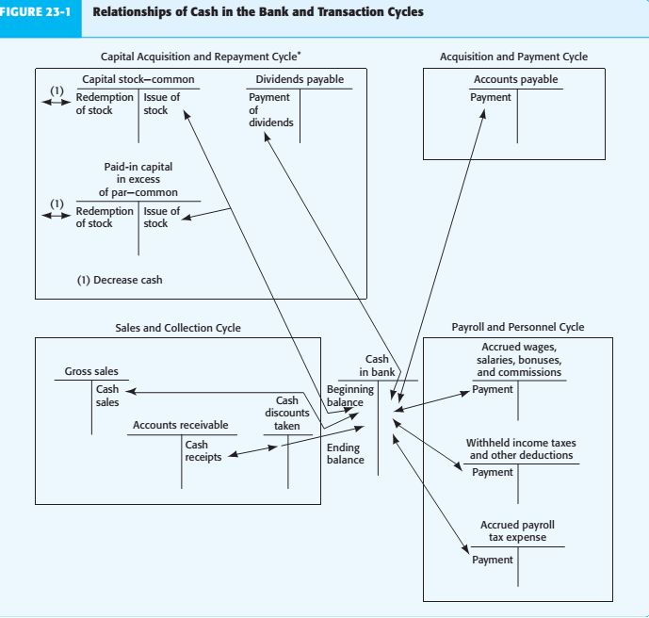
Audit of the General Cash Account
In testing the year-end balance in the general cash account, the auditor must accumulate sufficient appropriate evidence to evaluate whether cash, as stated on the balance sheet, is fairly stated and properly disclosed in accordance with five balance-related audit objectives used for all tests of details of balances (existence, completeness, accuracy, cutoff, and detail tie-in).
PHASE I
- Identify Client Business Risks Affecting Cash
Most companies are unlikely to have significant client business risks affecting cash balances. However, client business risk may arise from inappropriate cash management policies or handling of funds held in trust for others.
Client business risk is more likely to arise from cash equivalents and other types of investments. Several financial services firms have suffered large trading losses from the activities of individual traders that were hidden by misstating investment and cash balances. The auditor should understand the risks from the client’s investment policies and strategies, as well as management controls that mitigate these risks.
- Set Tolerable Misstatement and Assess Inherent Risk
The cash balance is not material on many audits, but cash transactions affecting the balance are almost always extremely material. Therefore, the potential often exists for material misstatement of cash.
Because cash is more susceptible to theft than other assets, there is high inherent risk for the existence, completeness, and accuracy objectives. These objectives are usually the focus in auditing cash balances.
- Assess Control Risk
Internal controls over year-end cash balances in the general account can be divided into two categories:
1. Controls over the transaction cycles affecting the recording of cash receipts and disbursements
2. Independent bank reconciliations
in the acquisition and payment cycle, major controls include adequate segregation of duties between the check signing and accounts payable functions, signing of checks only by a properly authorized person, use of pre-numbered checks printed on special paper, careful review of supporting documentation by the check signer before checks are signed, and adequate internal verification. Similar controls apply to electronic payments. If controls affecting cash-related transactions are operating effectively, control risk is reduced as are the audit tests for the year-end bank reconciliation.
A monthly bank reconciliation of the general bank account on a timely basis by someone independent of the handling or recording of cash receipts and disbursements is an essential control over the ending cash balance. The reconciliation ensures that the accounting records reflect the same cash balance as the actual amount of cash in the bank after considering reconciling items. More important, the independent reconciliation provides an opportunity for an internal verification of cash receipts and disbursements transactions.
Careful bank reconciliation by competent client personnel includes the following actions:
• Compare cancelled checks or electronic bank records of payment with the cash disbursements records for date, payee, and amount
• Examine cancelled checks or electronic bank records of payment for signature, endorsement, and cancellation
• Compare deposits in the bank with recorded cash receipts for date, customer, and amount
Account for the numerical sequence of checks, and investigate missing ones
• Reconcile all items causing a difference between the book and bank balance and verify their appropriateness for the client’s business
• Reconcile total debits on the bank statement with the totals in the cash disbursements records
• Reconcile total credits on the bank statement with the totals in the cash receipts records
PHASE II Design and Perform Tests of Controls and Substantive Tests of Transactions ( arens page 461)
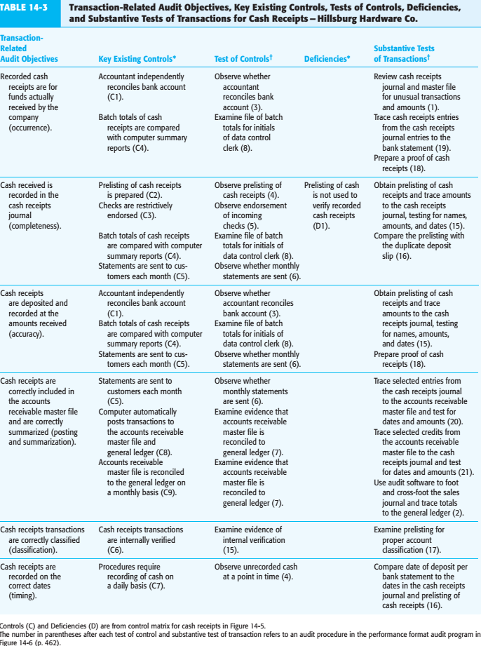
PHASE III
- Design and Perform Analytical Procedures
Auditors commonly compare the ending balance on the bank reconciliation, deposits in transit, outstanding checks, and other reconciling items with the prior-year reconciliation. Similarly, auditors normally compare the ending balance in cash with previous months’ balances. These analytical procedures may uncover misstatements in cash.
- Design Tests of Details of Cash Balance
The starting point for the verification of the balance in the general bank account is to obtain bank reconciliation from the client for inclusion in the auditor’s documentation.
To audit cash in the bank, the auditor verifies whether the bank reconciliation received from the client is correct. The balance-related audit objectives and common tests of details of balances in the audit of the cash account are shown in Table 23-1 (p. 739). The most important objectives are existence, completeness, and accuracy. Therefore, they receive the greatest attention. In addition to these balance-related objectives, the auditor also performs tests related to the four presentation and disclosure objectives, such as review of minutes and loan agreements to determine if there are restrictions on cash that must be disclosed.
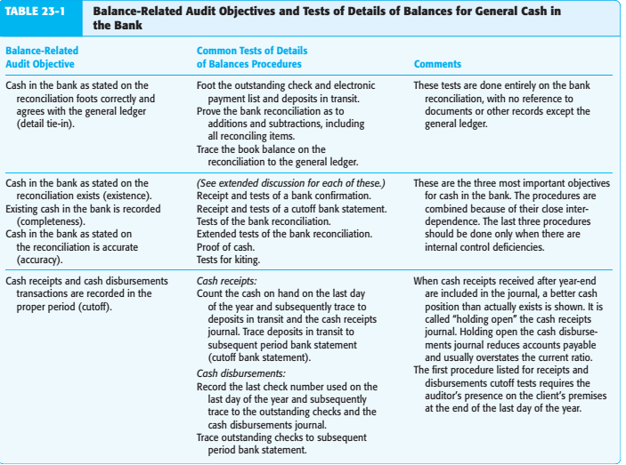
The following three cash audit procedures merit additional discussion because of their importance and complexity: receipt of a bank confirmation, receipt of a cutoff bank statement, and tests of the bank reconciliation.
- Receipt of a Bank Confirmation
If the bank does not respond to a confirmation request, the auditor should send a second request or ask the client to communicate with the bank to ask them to complete and return the confirmation to the auditor. As a convenience to auditors as well as to bankers who are requested to fill out bank confirmations, the AICPA has approved the use of a standard bank confirmation form.
- Receipt of a Cutoff Bank Statement
A cutoff bank statement is a partial-period bank statement and the related copies of cancelled checks, duplicate deposit slips, and other documents included in bank statements, mailed by the bank directly to the CPA firm’s office. The purpose of the cutoff bank statement is to verify the reconciling items on the client’s year-end bank reconciliation with evidence that is not accessible to the client. To fulfill this purpose, the auditor requests the client to have the bank send the statement for 7 to 10 days subsequent to the balance sheet date directly to the auditor.
Many auditors verify the subsequent period bank statement if a cutoff statement is not received directly from the bank. The purpose is to test whether the client’s employees have omitted, added, or altered any of the documents accompanying the statement.
Obviously, this tests for intentional misstatements. The auditor performs the following verification in the month subsequent to the balance sheet date:
• Foot the lists of all cancelled checks, debit memos, deposits, and credit memos
• Verify that the bank statement balances when the footed totals are used
• Review the items included in the footings to make sure that they were cancelled by the bank in the proper period and do not include any erasures or alterations
- Tests of the Bank Reconciliation
A Well-prepared independent bank reconciliation is an essential internal control over cash. Auditors test the bank reconciliation to determine whether client personnel have carefully prepared the bank reconciliation and to verify whether the client’s recorded bank balance is the same amount as the actual cash in the bank except for deposits in transit, outstanding checks, and other reconciling items.
In verifying the reconciliation, the auditor uses information in the cutoff bank statement to verify the appropriateness of reconciling items. The auditor’s verification of the reconciliation involves several procedures:
• Verify that the client’s bank reconciliation is mathematically accurate.
• Trace the balance on the bank confirmation and/or the beginning balance on the cutoff statement to the balance per bank on the bank reconciliation to ensure they are the same.
• Trace checks written and recorded before year-end and included with the cutoff bank statement to the list of outstanding checks on the bank reconciliation and to the cash disbursements journal in the period or periods prior to the balance sheet date. All checks that cleared the bank after the balance sheet date and were included in the cash disbursements journal should also be included on the outstanding check list.
MARKETABLE SECURITIES:
The most important group of investments, from the viewpoint of the auditors, consists of stock and bonds because they are found more frequently and usually are of greater dollar value than other kinds of investment holdings. Bank certificates of deposit, commercial paper issued by corporations and the cash surrender value of life insurance policies are other types of investments often encountered. Investment of temporarily idle cash in selected types of marketable securities is an element of good financial management. Such holding are regarded as a secondary cash reserve, capable of quick conversion to cash at any time, although producing low rate of return.
The auditors’ objectives in examination of marketable securities:
The auditors’ objectives in the examination of marketable securities are to determine that:
- Internal control over marketable securities is adequate
- Marketable securities are valid in that they exist and are the property of the client (existence and rights)
- All marketable securities are recorded (completeness)
- Valuation of marketable securities is in accordance with the lower of cost or market method of accounting (valuations)
- Marketable security records and schedule are mathematically correct and agree with general ledger accounts (clerical accuracy)
- The presentation and disclosure of marketable securities, including current/noncurrent classification and necessary disclosures, is adequate.
Internal control of marketable securities:
The major elements of adequate internal control over marketable securities include the following:
- Separation of duties between the executive authorizing purchases and sales of securities, the custodian of the securities, and the person maintaining the record of investments.
- Complete detailed records of all securities owned and the related revenue from interest and dividends.
- Registration of securities in the name of the company
- Periodic physical inspection of securities by an internal auditor or an official having no responsibility for the authorization, custody, or record keeping of investments.
Audit procedures for securities:
Listed below are procedures typically performed by auditors to achieve the objectives described earlier:
A) Consider internal control for securities:
- Obtain an understanding of internal control for securities
- Assess control risk and design additional tests of controls for securities
- Perform additional tests of controls for those controls the auditors plan to rely upon to restrict their assessment of control risk, and reduce the extent of substantive testing such as:
  - trace transactions for purchases and sales of securities through the system
  - Review reports by internal auditors on their periodic inspection of securities
  - Review monthly reports by officers of the client’s company on securities owned, purchases and sold, and revenue earned
- Reassess control risk and design substantive tests for securities
B) SUBSTANTIVE TEST
- Obtain or prepare analyses of the securities investment account and related revenue accounts and reconcile top the general ledger
- Inspect securities on hand and compare serial numbers with those shown on previous examinations
- Obtain confirmation of securities held by others.
- Vouch purchases and sales of securities during the year
- Determine market value of securities at date of balance sheet
- perform analytical procedures
- Make independent computations of revenue from securities
- Verify the client’s cutoff of securities transactions
- Evaluate the method of accounting for securities
- Evaluate financial statement presentation and disclosure of securities.

