CHAPTER 3
AUDIT OF RECEIVABLES AND SALES
2. ACCOUNTS RECEIVABLE, NOTES RECEIVABLE, AND SALES TRANSACTIONS:
Sources and Nature of receivables:
- The Receivable include not only Claims against customers arising from the sale of goods or services
- But also a variety of miscellaneous claims such as loans to officers or employees, loan to subsidiaries, uncollected stock subscriptions, claim against various other firms, claims for tax refunds, and advances to suppliers.
- Trade notes and accounts receivable usually are relatively large in amount and should appear as separate items in the current assets section of the balance sheet at their net realizable value.
- Auditors are especially concerned with the presentation and disclosure of loans to officers, directors, and affiliated companies.
Auditor’s objectives in examination of receivables:
- Internal control over receivables is adequate
- The recorded receivables are valid (existence and rights)
- All receivables are recorded (completeness)
- Receivable records and supporting schedules are mathematically correct and agree with general ledger accounts (clerical accuracy)
- The valuation of receivables approximates their realizable value
- The presentation and disclosure of receivables is adequate, including the separation of receivables into appropriate categories, and adequate reporting of any receivables pledged as collateral and related party receivables.

Objectives of internal control:
- All orders received are filled promptly
- Credit is approved before goods are released for shipment
- Customers are correctly billed for all merchandise released by the shipping department
- All receivables resulting from completed sales transactions are correctly recorded
- Credits for returns, allowances and bad debt writ-off are properly authorized
- Amounts receivable from customers are collected if at all possible
- Collections on receivables are fully accounted for.
- Reports adequately summarize sales and credit activities and reveal the current status of uncollected receivables.
Audit procedures for Receivables and sales Transactions:
- Obtain an understanding of internal control
- Assess control risk and design additional tests of controls
- perform additional tests of controls
- Reconcile selected cash register tapes and sales tickets with sales journals
- Obtain and aged trail balance of trade account receivable and analyses of other accounts receivables and reconcile to ledgers
- Obtain analyses of notes receivable and related interest
- inspect notes on hand and confirm those not on hand with holders
- Confirm receivables with debtors
- Review the year-end cutoff sales transaction
- perform analytical procedures for accounts receivable, sales, notes receivable, and interest revenue
- verify interest earned and notes and accrued interest receivable
- Determine adequacy of allowance for uncollectible account
- Ascertain whether any receivables have pledged
- Investigate fully any notes or accounts receivable from related parties
- Evaluate financial statement presentation and disclosure

Figure 14-1 (p.442) shows typical accounts included in the sales and collection cycle using T accounts.
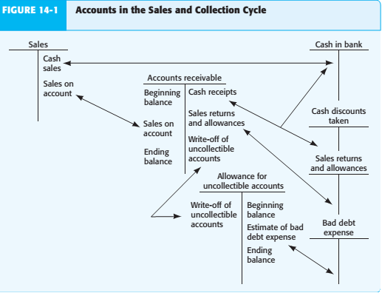

Methodology for designing tests of controls and substantive tests of transactions for sales Figure 14-2 (p.447)
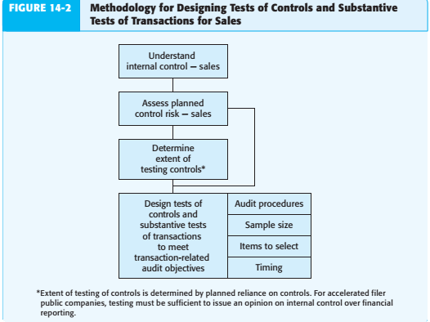
- Understand Internal Control — Sales: How do auditors obtain an understanding of internal control? Using one typical approach for sales, auditors study the client’s flowcharts, make inquiries of the client using an internal control questionnaire, and perform walkthrough tests of sales
- Assess Planned Control Risk — Sales: The auditor uses the information obtained in understanding internal control to assess control risk. Knowledge of these control activities assists in identifying the key controls and deficiencies for sales. Adequate Separation of Duties Proper separation of duties helps prevent various types of misstatements due to both errors and fraud. To prevent fraud, management should deny cash access to anyone responsible for entering sales and cash receipts transaction information into the computer.
- Determine Extent of Testing Controls: In determining the extent of reliance to place on controls, the auditor also considers the cost of the increased tests of controls compared to the potential reduction in substantive tests.
- Design Tests of Controls for Sales: For each key control, one or more tests of controls must be designed to verify its effectiveness.
- Design Substantive Tests of Transactions for Sales: In deciding substantive tests of transactions, auditors commonly use some procedures on every audit regardless of the circumstances, whereas others are dependent on the adequacy of the controls and the results of the tests of controls.(table 14-2 p.452)
