CHAPTER 6
AUDIT OF ACCOUNTS PAYABLE AND OTHER LIABLITIES
Sources and nature of accounts payable:
The term accounts payable (often referred to as vouchers payable for a voucher system) is used to describe short-term obligations arising from the purchase of goods and services in the ordinary course of business. Typical transactions creating accounts payable include the acquisition on credit of merchandise, raw materials, plant assets, and office supplies. Other sources of accounts payable include the receipt of services, such as legal and accounting services, advertising, repairs, and utilities. Interest-bearing obligations should not be included in accounts payable but shown separately as bonds, notes, mortgages or installment contracts.
The auditors’ approach in examination of accounts payable:
The auditors’ objectives in the examination of accounts payable are to determine that:
- Internal control over accounts payable and the acquisition and payment cycle is adequate.
- The recorded accounts payable are valid (occurrence and obligations)
- All accounts payable are recorded (completeness)
- Accounts payable schedules are mathematically correct and agree with general ledger accounts (clerical accuracy).
- The valuation of accounts payable is proper
- The presentation and disclosure of payables is adequate.
Audit Procedures:
A) Consider internal control for accounts payable:
- Obtain an understanding of the internal control
- Assess control risk and design additional test of controls.
- Perform additional tests of controls
  - Verify a sample of postings to the accounts payable controlling account.
  - Vouch to supporting documents a sample of postings in selected accounts of the a/p subsidiary ledger
- Reassess control risk and design substantive tests
B) Substantive tests:
- Obtain or prepare a trail balance of accounts payable as of the balance sheet date and reconcile with the general ledger
- Vouch balances payable to selected creditors by inspection of supporting documents.
- Reconcile liabilities with monthly statements from creditors
- Confirm accounts payable by direct correspondence with vendor
- Perform analytical procedures for accounts payable and related accounts
- Search for unrecorded accounts payable
- Search for accounts payable to related parties
- Evaluate proper balance sheet presentation and disclosure of accounts payable

Other Liabilities
In addition to the accounts payable previously considered, other items classified as current liabilities include:
- Amounts withheld from employees’ pay
- Sales taxes payable
- Unclaimed wages
- Customer’s deposits
- Accrued liabilities
a) Amount withheld from employee’s pay
Income taxes withheld from employees’ pay and not remitted as of the balance sheet date constitute a liability to be verified by the auditors. Accrued employer payroll taxes may be audited at the same time. This verification usually consisted of tracing the amounts withheld to the payroll summary sheets, testing computations of taxes withheld and accrued and determining that taxes have been deposited or paid in accordance with the federal and state laws and regulations.
b) Sales taxes payable:
In most sections of the country, business concerns are required to collect taxes imposed by state and local governments on retails sales. These taxes do not represent expenses to the business; the retailer merely acts as a collecting agent. Until the amounts collected from the customers are remitted to the taxing authority, they constitute current liabilities of the business. The auditors’ verification of this liability includes a review of the client’s periodic tax returns. The reasonableness of the liability also is tested by a computation applying the tax rate to total taxable sales. In addition, the auditors should examine a number of sales invoices to ascertain that customers are being charged the correct amount of tax. Debits- to the liability account for remittances to the taxing authority should be traced to copies of the tax returns and should be vouched to the paid checks.
c) Unclaimed wages:
The auditors will analysis the unclaimed wages account for the purpose of determining that:
- The credits represent all unclaimed wages after each payroll distribution and
- The debits represent only authorized payments to employee, remittances to the state under unclaimed property lay, or transfers back to general cash funds through approved procedures.
d) Customer’s deposits
Many companies require that customers make deposits returnable containers. A review of the procedures followed in accepting and returning deposits should be made by the auditors with a view to disclosing any shortcomings in internal control. In some instances, deposits shown by the records as refunded to customers may in fact have been abstracted by employees.
As a general rule, the auditors do not attempt to confirm deposits by direct communication with customers; but this procedure is desirable if the amounts involved are substantial to the internal control procedures are considered to be deficient.
e) Accrued liabilities
Most accrued liabilities represent obligations payable sometime during the succeeding period for services or privileges received before the balance sheet date. Examples include interest payable, accrued property taxes, accrued payrolls and payroll taxes and income taxes payable.
Because accrued items are based on client estimates of amounts which will subsequently become payable, subjective factors may make it difficult to establish control over them. As a result, these estimates may be particularly liable to misstatement, especially in circumstances in which management is under pressure to show increased earnings.

The Basic auditing steps for accrued liabilities are:
- Examine any contracts or other documents on hand that provide the basis for the accrual
- Appraise the accuracy of the detailed accounting records maintained for this category of liability
- Identify and evaluate the reasonableness of the assumptions made that underline the computation of the liability
- Test the computation made by the client in setting up the accrual.
- Determine that accrued liabilities have been treated consistently at the beginning and end of the period
- Consider the need for accrual of other accrued liabilities not presently considered (that is, test completeness).
Design and perform audit tests of notes payable
A note payable is a legal obligation to a creditor, which may be unsecured or secured by assets, and bears interest. Notes are issued for different purposes, and the property pledged as collateral includes a wide variety of assets, such as securities, accounts receivable, inventory, and fixed assets. The principal and interest payments on the notes must be made in accordance with the terms of the loan agreement. For short-term loans, a principal and interest payment is usually required only when the loan becomes due. For loans over 90 days, the note usually calls for monthly or quarterly interest payments.
The objectives of the audit of notes payable are to determine whether:
- Internal controls over notes payable are adequate.
- Transactions for principal and interest involving notes payable are properly authorized and recorded in accordance with the six transaction-related audit objectives.
- The liability for notes payable and the related interest expense and accrued liability are properly stated
There are four important controls over notes payable:
- Proper authorization for the issue of new notes. Responsibility for the issuance of new notes should be vested in the board of directors or high-level management personnel. Generally, two signatures of properly authorized officials are required for all loan agreements, which usually stipulate the amount of the loan, the interest rate, the repayment terms, and the assets pledged. When notes are renewed, they need to be subject to the same authorization procedures as those for the issuance of new notes.
- Adequate controls over the repayment of principal and interest. The periodic payments of interest and principal should be subject to the controls in the acquisition and payment cycle. At the time the note was issued, the accounting department should have received a copy of the note, much like it receives vendors’ invoices and receiving reports. The accounts payable department should automatically issue checks or electronic fund transfers for the notes when they become due, again in the same manner in which it prepares payments for acquisitions of goods and services. A copy of the note provides the supporting documentation for payment.
- Proper documents and records. These include subsidiary records and control over blank and paid notes by an authorized person. Paid notes should be cancelled and retained under the custody of an authorized official.
- Periodic independent verification. Periodically, the detailed note records should be reconciled with the general ledger and compared with the note holders’ records by an employee who is not responsible for maintaining the detailed records. At the same time, an independent person should re-compute the interest expense on notes to test the accuracy of the record keeping
Tests of Controls and Substantive Tests of Transactions
Tests of notes payable transactions involve the issue of notes and the repayment of principal and interest. These audit tests are a part of tests of controls and substantive tests of transactions for cash receipts and cash disbursements. Additional tests of controls and substantive tests of transactions are often done as a part of tests of details of balances because of the materiality of individual transactions.
Tests of controls for notes payable and related interest should emphasize testing the four internal controls we just discussed. In addition, auditors should verify the accurate recording of receipts from note proceeds and payments of principal and interest.
Analytical Procedures
The auditor’s independent prediction of interest expense, using average notes payable outstanding and average interest rates, helps the auditor evaluate the reasonableness of interest expense and also tests for omitted notes payable.
Tests of Details of Balances
The normal starting point for the audit of notes payable is a schedule of notes payable and accrued interest, which the auditor obtains from the client. Figure 22-2 (pp. 716–717) illustrates a typical schedule, including detailed information of all transactions that took place during the entire year for principal and interest, the beginning and ending balances for notes and interest payable, and descriptive information about the notes, such as the due date, the interest rate, and the assets pledged as collateral.

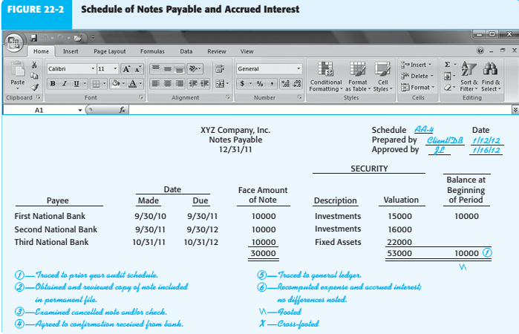

When there are numerous transactions involving notes during the year, it may be impractical for auditors to obtain such a schedule. In those situations, auditors are likely to request the client to prepare a schedule of only those notes with unpaid balances at the end of the year, showing a description of each note, its ending balance, and the interest payable at the end of the year, including the collateral and interest rate.
Table 22-2 (p. 718) summarizes the applicable balance-related audit objectives and common audit procedures as they apply to the schedule of notes payable. Again, the amount of testing depends heavily on the materiality of notes payable and the effectiveness of internal controls.
The two most important balance-related audit objectives in notes payable are:
1. Existing notes payable are included (completeness).
2. Notes payable in the schedule are accurately recorded (accuracy)
