Chapter 2: Data Science

Introduction
In the previous chapter, the concept of the role of data for emerging technologies was discussed. In this chapter, you are going to learn more about data science, data vs. information, data types and representation, data value chain, and basic concepts of big data.
After completing this chapter, the students will be able to:
- Describe what data science is and the role of data scientists.
- Differentiate data and information.
- Describe data processing life cycle
- Understand different data types from diverse perspectives
- Describe data value chain in emerging era of big data.
- Understand the basics of Big Data.
- Describe the purpose of the Hadoop ecosystem components.

2.1. An Overview of Data Science

Activity 2.1
- What is data science? Can you describe the role of data in emerging technology?
- What are data and information?
- What is big data?
Data science is a multi-disciplinary field that uses scientific methods, processes, algorithms, and systems to extract knowledge and insights from structured, semi-structured and unstructured data. Data science is much more than simply analyzing data. It offers a range of roles and requires a range of skills.
Let’s consider this idea by thinking about some of the data involved in buying a box of cereal from the store or supermarket:
- Whatever your cereal preferences—teff, wheat, or burly—you prepare for the purchase by writing “cereal” in your notebook. This planned purchase is a piece of data though it is written by pencil that you can read.
- When you get to the store, you use your data as a reminder to grab the item and put it in your cart. At the checkout line, the cashier scans the barcode on your container, and the cash register logs the price. Back in the warehouse, a computer tells the stock manager that it is time to request another order from the distributor because your purchase was one of the last boxes in the store.
- You also have a coupon for your big box, and the cashier scans that, giving you a predetermined discount. At the end of the week, a report of all the scanned manufacturer coupons gets uploaded to the cereal company so they can issue a reimbursement to the grocery store for all of the coupon discounts they have handed out to customers. Finally, at the end of the month, a store manager looks at a colorful collection of pie charts showing all the different kinds of cereal that were sold and, on the basis of strong sales of cereals, decides to offer more varieties of these on the store’s limited shelf space next month.
- So, the small piece of information that began as a scribble on your notebook ended up in many different places, most notably on the desk of a manager as an aid to decision making.
- On the trip from your pencil to the manager’s desk, the data went through many transformations. In addition to the computers where the data might have stopped by or stayed on for the long term, lots of other pieces of hardware—such as the barcode scanner—were involved in collecting, manipulating, transmitting, and storing the data. In addition, many different pieces of software were used to organize, aggregate, visualize, and present the data. Finally, many different human systems were involved in working with the data. People decided which systems to buy and install, who should get access to what kinds of data, and what would happen to the data after its immediate purpose was fulfilled.
As an academic discipline and profession, data science continues to evolve as one of the most promising and in-demand career paths for skilled professionals. Today, successful data professionals understand that they must advance past the traditional skills of analyzing large amounts of data, data mining, and programming skills. In order to uncover useful intelligence for their organizations, data scientists must master the full spectrum of the data science life cycle and possess a level of flexibility and understanding to maximize returns at each phase of the process. Data scientists need to be curious and result-oriented, with exceptional industry-specific knowledge and communication skills that allow them to explain highly technical results to their non-technical counterparts. They possess a strong quantitative background in statistics and linear algebra as well as programming knowledge with focuses on data warehousing, mining, and modeling to build and analyze algorithms. In this chapter, we will talk on basic definitions of data and information, data types and representation, data value change and basic concepts of big data.

Activity 2.2
- Describe in some detail the main disciplines that contribute to data science.
- Let the teacher explain the role of data scientists and students may write a small report on the same.
2.1.1. What are data and information?
Data can be defined as a representation of facts, concepts, or instructions in a formalized manner, which should be suitable for communication, interpretation, or processing, by human or electronic machines. It can be described as unprocessed facts and figures. It is represented with the help of characters such as alphabets (A-Z, a-z), digits (0-9) or special characters (+, -, /, *, <,>, =, etc.). Whereas information is the processed data on which decisions and actions are based. It is data that has been processed into a form that is meaningful to the recipient and is of real or perceived value in the current or the prospective action or decision of recipient. Further more, information is interpreted data; created from organized, structured, and processed data in a particular context.
2.1.2. Data Processing Cycle
Data processing is the re-structuring or re-ordering of data by people or machines to increase their usefulness and add values for a particular purpose. Data processing consists of the following basic steps - input, processing, and output. These three steps constitute the data processing cycle.
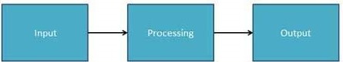
Figure 2.1 Data Processing Cycle
- Input ₋ in this step, the input data is prepared in some convenient form for processing. The form will depend on the processing machine. For example, when electronic computers are used, the input data can be recorded on any one of the several types of storage medium, such as hard disk, CD, flash disk and so on.
- Processing ₋ in this step, the input data is changed to produce data in a more useful form. For example, interest can be calculated on deposit to a bank, or a summary of sales for the month can be calculated from the sales orders.
- Output ₋ at this stage, the result of the proceeding processing step is collected. The particular form of the output data depends on the use of the data. For example, output data may be payroll for employees.
Activity 2.3
  - Discuss the main differences between data and information with examples.
  - Can we process data manually using a pencil and paper? Discuss the differences with data processing using the computer.

2.3 Data types and their representation
Data types can be described from diverse perspectives. In computer science and computer programming, for instance, a data type is simply an attribute of data that tells the compiler or interpreter how the programmer intends to use the data.
2.3.1. Data types from Computer programming perspective
Almost all programming languages explicitly include the notion of data type, though different languages may use different terminology. Common data types include:
- Integers(int)- is used to store whole numbers, mathematically known as integers
- Booleans(bool)- is used to represent restricted to one of two values: true or false
- Characters(char)- is used to store a single character
- Floating-point numbers(float)- is used to store real numbers
- Alphanumeric strings(string)- used to store a combination of characters and numbers
A data type makes the values that expression, such as a variable or a function, might take. This data type defines the operations that can be done on the data, the meaning of the data, and the way values of that type can be stored.
2.3.2. Data types from Data Analytics perspective
From a data analytics point of view, it is important to understand that there are three common types of data types or structures: Structured, Semi-structured, and Unstructured data types. Fig. 2.2 below describes the three types of data and metadata.
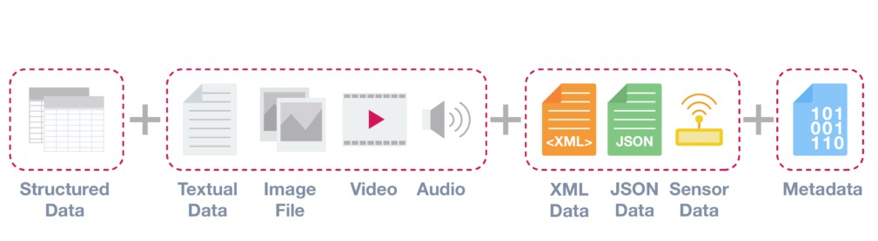 Figure 2.2 Data types from a data analytics perspective

Structured Data
Structured data is data that adheres to a pre-defined data model and is therefore straightforward to analyze. Structured data conforms to a tabular format with a relationship between the different rows and columns. Common examples of structured data are Excel files or SQL databases. Each of these has structured rows and columns that can be sorted.

Semi-structured Data
Semi-structured data is a form of structured data that does not conform with the formal structure of data models associated with relational databases or other forms of data tables, but nonetheless, contains tags or other markers to separate semantic elements and enforce hierarchies of records and fields within the data. Therefore, it is also known as a self-describing structure. Examples of semi-structured data include JSON and XML are forms of semi-structured data.

Unstructured Data
Unstructured data is information that either does not have a predefined data model or is not organized in a pre-defined manner. Unstructured information is typically text-heavy but may contain data such as dates, numbers, and facts as well. This results in irregularities and ambiguities that make it difficult to understand using traditional programs as compared to data stored in structured databases. Common examples of unstructured data include audio, video files or NoSQL databases.

Metadata – Data about Data
The last category of data type is metadata. From a technical point of view, this is not a separate data structure, but it is one of the most important elements for Big Data analysis and big data solutions. Metadata is data about data. It provides additional information about a specific set of data.
In a set of photographs, for example, metadata could describe when and where the photos were taken. The metadata then provides fields for dates and locations which, by themselves, can be considered structured data. Because of this reason, metadata is frequently used by Big Data solutions for initial analysis.

Activity 2.4
- Discuss data types from programing and analytics perspectives.
- Compare metadata with structured, unstructured and semi-structured data
- Given at least one example of structured, unstructured and semi-structured data types

2.4. Data value Chain
The Data Value Chain is introduced to describe the information flow within a big data system as a series of steps needed to generate value and useful insights from data. The Big Data Value Chain identifies the following key high-level activities:
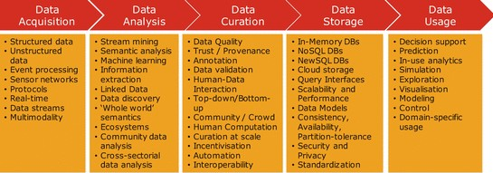

Figure 2.3 Data Value Chain
2.4.1. Data Acquisition
It is the process of gathering, filtering, and cleaning data before it is put in a data warehouse or any other storage solution on which data analysis can be carried out. Data acquisition is one of the major big data challenges in terms of infrastructure requirements. The infrastructure required to support the acquisition of big data must deliver low, predictable latency in both capturing data and in executing queries; be able to handle very high transaction volumes, often in a distributed environment; and support flexible and dynamic data structures.
2.4.2. Data Analysis
It is concerned with making the raw data acquired amenable to use in decision-making as well as domain-specific usage. Data analysis involves exploring, transforming, and modeling data with the goal of highlighting relevant data, synthesizing and extracting useful hidden information with high potential from a business point of view. Related areas include data mining, business intelligence, and machine learning.
2.4.3. Data Curation
It is the active management of data over its life cycle to ensure it meets the necessary data quality requirements for its effective usage. Data curation processes can be categorized into different activities such as content creation, selection, classification, transformation, validation, and preservation. Data curation is performed by expert curators that are responsible for improving the accessibility and quality of data. Data curators (also known as scientific curators or data annotators) hold the responsibility of ensuring that data are trustworthy, discoverable, accessible, reusable and fit their purpose. A key trend for the duration of big data utilizes community and crowdsourcing approaches.
2.4.4. Data Storage
It is the persistence and management of data in a scalable way that satisfies the needs of applications that require fast access to the data. Relational Database Management Systems (RDBMS) have been the main, and almost unique, a solution to the storage paradigm for nearly 40 years. However, the ACID (Atomicity, Consistency, Isolation, and Durability) properties that guarantee database transactions lack flexibility with regard to schema changes and the performance and fault tolerance when data volumes and complexity grow, making them unsuitable for big data scenarios. NoSQL technologies have been designed with the scalability goal in mind and present a wide range of solutions based on alternative data models.
2.4.5. Data Usage
It covers the data-driven business activities that need access to data, its analysis, and the tools needed to integrate the data analysis within the business activity. Data usage in business decision making can enhance competitiveness through the reduction of costs, increased added value, or any other parameter that can be measured against existing performance criteria.
Activity 2.5
- Which information flow step in the data value chain you think is labor-intensive?Why?
- What are the different data types and their value chain?

2.5. Basic concepts of big data
Big data is a blanket term for the non-traditional strategies and technologies needed to gather, organize, process, and gather insights from large datasets. While the problem of working with data that exceeds the computing power or storage of a single computer is not new, the pervasiveness, scale, and value of this type of computing have greatly expanded in recent years.
In this section, we will talk about big data on a fundamental level and define common concepts you might come across. We will also take a high-level look at some of the processes and technologies currently being used in this space.
2.5.1. What Is Big Data?
Big data is the term for a collection of data sets so large and complex that it becomes difficult to process using on-hand database management tools or traditional data processing applications.
In this context, a “large dataset” means a dataset too large to reasonably process or store with traditional tooling or on a single computer. This means that the common scale of big datasets is constantly shifting and may vary significantly from organization to organization. Big data is characterized by 3V and more:
- Volume: large amounts of data Zeta bytes/Massive datasets
- Velocity: Data is live streaming or in motion
- Variety: data comes in many different forms from diverse sources • Veracity: can we trust the data? How accurate is it? etc.
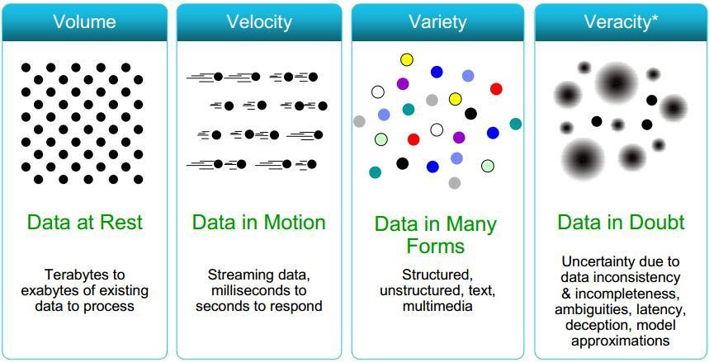
Figure 2.4 Characteristics of big data

2.5.2. Clustered Computing and Hadoop Ecosystem
2.5.2.1.Clustered Computing
Because of the qualities of big data, individual computers are often inadequate for handling the data at most stages. To better address the high storage and computational needs of big data, computer clusters are a better fit.
Big data clustering software combines the resources of many smaller machines, seeking to provide a number of benefits:
- Resource Pooling: Combining the available storage space to hold data is a clear benefit, but CPU and memory pooling are also extremely important. Processing large datasets requires large amounts of all three of these resources.
- High Availability: Clusters can provide varying levels of fault tolerance and availability guarantees to prevent hardware or software failures from affecting access to data and processing. This becomes increasingly important as we continue to emphasize the importance of real-time analytics.
- Easy Scalability: Clusters make it easy to scale horizontally by adding additional machines to the group. This means the system can react to changes in resource requirements without expanding the physical resources on a machine.
Using clusters requires a solution for managing cluster membership, coordinating resource sharing, and scheduling actual work on individual nodes. Cluster membership and resource allocation can be handled by software like Hadoop’s YARN (which stands for Yet Another Resource
Negotiator).
The assembled computing cluster often acts as a foundation that other software interfaces with to process the data. The machines involved in the computing cluster are also typically involved with the management of a distributed storage system, which we will talk about when we discuss data persistence.
Activity 2.6
- List and discuss the characteristics of big data
- Describe the big data life cycle. Which step you think most useful and why?
- List and describe each technology or tool used in the big data life cycle.
- Discuss the three methods of computing over a large dataset.
2.5.2.2.Hadoop and its Ecosystem
Hadoop is an open-source framework intended to make interaction with big data easier. It is a framework that allows for the distributed processing of large datasets across clusters of computers using simple programming models. It is inspired by a technical document published by Google.
The four key characteristics of Hadoop are:
- Economical: Its systems are highly economical as ordinary computers can be used for data processing.
- Reliable: It is reliable as it stores copies of the data on different machines and is resistant to hardware failure.
- Scalable: It is easily scalable both, horizontally and vertically. A few extra nodes help in scaling up the framework.
- Flexible: It is flexible and you can store as much structured and unstructured data as you need to and decide to use them later.
Hadoop has an ecosystem that has evolved from its four core components: data management, access, processing, and storage. It is continuously growing to meet the needs of Big Data. It comprises the following components and many others:
- HDFS: Hadoop Distributed File System
- YARN: Yet Another Resource Negotiator
- MapReduce: Programming based Data Processing
- Spark: In-Memory data processing
- PIG, HIVE: Query-based processing of data services
- HBase: NoSQL Database
- Mahout, Spark MLLib: Machine Learning algorithm libraries
- Solar, Lucene: Searching and Indexing
- Zookeeper: Managing cluster
Activity 2.7
➢ Students in a group shall discuss the purpose of each Hadoop Ecosystem components?

- Oozie: Job Scheduling
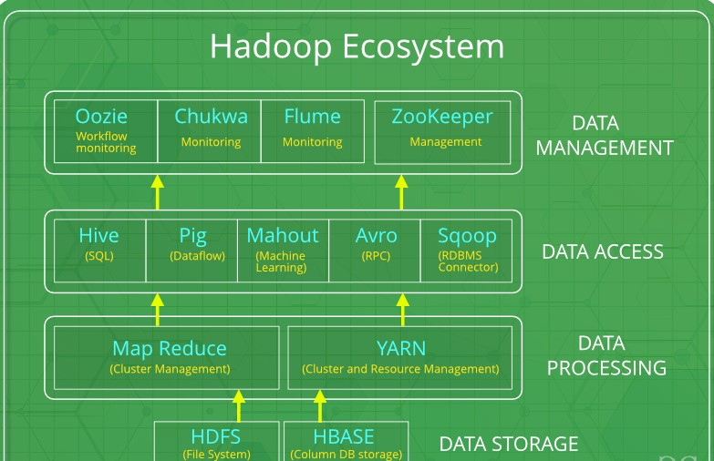
Figure 2.5 Hadoop Ecosystem
2.5.3. Big Data Life Cycle with Hadoop
2.5.3.1. Ingesting data into the system
The first stage of Big Data processing is Ingest. The data is ingested or transferred to Hadoop from various sources such as relational databases, systems, or local files. Sqoop transfers data from RDBMS to HDFS, whereas Flume transfers event data.
2.5.3.2. Processing the data in storage
The second stage is Processing. In this stage, the data is stored and processed. The data is stored in the distributed file system, HDFS, and the NoSQL distributed data, HBase. Spark and MapReduce perform data processing.
2.5.3.3. Computing and analyzing data
The third stage is to Analyze. Here, the data is analyzed by processing frameworks such as Pig, Hive, and Impala. Pig converts the data using a map and reduce and then analyzes it. Hive is also based on the map and reduce programming and is most suitable for structured data.
2.5.3.4. Visualizing the results
The fourth stage is Access, which is performed by tools such as Hue and Cloudera Search. In this stage, the analyzed data can be accessed by users.
Chapter Two Review Questions
- Define data science; what are the roles of a data scientist?
- Discuss data and its types from computer programming and data analytics perspectives?
- Discuss a series of steps needed to generate value and useful insights from data?
- What is the principal goal of data science?
- List out and discuss the characteristics of Big Data?
- How we ingest streaming data into Hadoop Cluster?

Chapter 3: Artificial Intelligence (AI)

Introduction
In the previous chapter you have been studied about data science, how data acquisition, analyzed and stored. Basic concepts of big data were also studied. In this chapter, artificial intelligence, history, types, and applications in different sectors are studied. Finally, some tools and platforms, as well as a real sample of AI applications, are discussed.
After completing this chapter, the students will be able to:
- Explain what artificial intelligence (AI) is.
- Describe the eras of AI.
- Explain the types and approaches of AI.
- Describe the applications of AI in health, agriculture, business and education ➢ List the factors that influenced the advancement of AI in recent years.
- Understand the relationship between the human’s way of thinking and AI systems ➢ Identify AI research focus areas.
- Identify real-world AI applications, some platforms, and tools.

3.1. What is Artificial Intelligence (AI)
Artificial Intelligence is composed of two words Artificial and Intelligence.
Artificial defines "man-made," and intelligence defines "thinking power", or “the ability to learn and solve problems” hence Artificial Intelligence means "a man-made thinking power."
So, we can define Artificial Intelligence (AI) as the branch of computer science by which we can create intelligent machines which can behave like a human, think like humans, and able to make decisions.
Intelligence, as we know, is the ability to acquire and apply knowledge. Knowledge is the information acquired through experience. Experience is the knowledge gained through exposure (training). Summing the terms up, we get artificial intelligence as the “copy of something natural (i.e., human beings) ‘WHO’ is capable of acquiring and applying the information it has gained through exposure.”
Artificial Intelligence exists when a machine can have human-based skills such as learning, reasoning, and solving problems with Artificial Intelligence you do not need to preprogram a machine to do some work, despite that you can create a machine with programmed algorithms which can work with own intelligence.
Intelligence is composed of:
- Reasoning
- Learning
- Problem Solving
- Perception
- Linguistic Intelligence
An AI system is composed of an agent and its environment. An agent (e.g., human or robot) is anything that can perceive its environment through sensors and acts upon that environment through effectors. Intelligent agents must be able to set goals and achieve them. In classical planning problems, the agent can assume that it is the only system acting in the world, allowing the agent to be certain of the consequences of its actions. However, if the agent is not the only actor, then it requires that the agent can reason under uncertainty. This calls for an agent that cannot only assess its environment and make predictions but also evaluate its predictions and adapt based on its assessment. Machine perception is the ability to use input from sensors (such as cameras, microphones, sensors, etc.) to deduce aspects of the world. e.g., Computer Vision.
High-profile examples of AI include autonomous vehicles (such as drones and self-driving cars), medical diagnosis, creating art (such as poetry), proving mathematical theorems, playing games (such as Chess or Go), search engines (such as Google search), online assistants (such as Siri), image recognition in photographs, spam filtering, prediction of judicial decisions and targeting online advertisements
AI deals with the area of developing computing systems that are capable of performing tasks that humans are very good at, for example recognizing objects, recognizing and making sense of speech, and decision making in a constrained environment.
The advent of Big Data, driven by the arrival of the internet, smart mobile and social media has enabled AI algorithms, in particular from Machine Learning and Deep Learning, to leverage Big Data and perform their tasks more optimally. This combined with cheaper and more powerful hardware such as Graphical Processing Units (GPUs) has enabled AI to evolve into more complex architectures. Machine Learning is an advanced form of AI where the machine can learn as it goes rather than having every action programmed by humans.
Many times, students get confused between Machine Learning and Artificial Intelligence (see figure 3.1), but Machine learning, a fundamental concept of AI research since the field’s inception, is the study of computer algorithms that improve automatically through experience. The term machine learning was introduced by Arthur Samuel in 1959. Neural networks are biologically inspired networks that extract features from the data in a hierarchical fashion. The field of neural networks with several hidden layers is called deep learning.
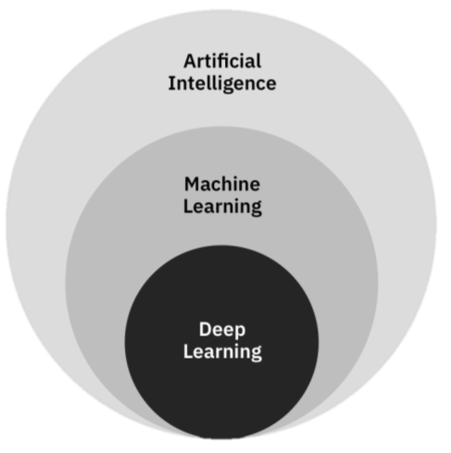
Figure 3.1 Artificial Intelligence (AI), Machine Learning (ML) and Deep Learning (DL)

3.1.1. Need for Artificial Intelligence
- To create expert systems that exhibit intelligent behavior with the capability to learn, demonstrate, explain and advice its users.
- Helping machines find solutions to complex problems like humans do and applying them as algorithms in a computer-friendly manner.

3.1.2. Goals of Artificial Intelligence
Following are the main goals of Artificial Intelligence:
- Replicate human intelligence
- Solve Knowledge-intensive tasks
- An intelligent connection of perception and action
- Building a machine which can perform tasks that requires human intelligence such as:
  - Proving a theorem
  - Playing chess
  - Plan some surgical operation
  - Driving a car in traffic
- Creating some system which can exhibit intelligent behavior, learn new things by itself, demonstrate, explain, and can advise to its user.

3.1.3. What Comprises to Artificial Intelligence?
Artificial Intelligence is not just a part of computer science even it's so vast and requires lots of other factors that can contribute to it. To create the AI-first we should know that how intelligence is composed, so Intelligence is an intangible part of our brain which is a combination of Reasoning, learning, problem-solving, perception, language understanding, etc.
To achieve the above factors for a machine or software Artificial Intelligence requires the following disciplines (see Figure 3.2):
- Mathematics
- Biology
- Psychology
- Sociology
- Computer Science
- Neurons Study
- Statistics
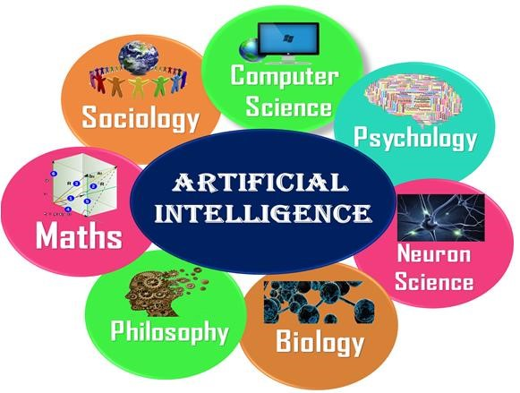
Figure 3.2 Artificial Intelligence is multidisciplinary

3.1.4. Advantages of Artificial Intelligence
Following are some main advantages of Artificial Intelligence:
- High Accuracy with fewer errors: AI machines or systems are prone to fewer errors and high accuracy as it takes decisions as per pre-experience or information.
- High-Speed: AI systems can be of very high-speed and fast-decision making, because of that AI systems can beat a chess champion in the Chess game.
- High reliability: AI machines are highly reliable and can perform the same action multiple times with high accuracy.
- Useful for risky areas: AI machines can be helpful in situations such as defusing a bomb, exploring the ocean floor, where to employ a human can be risky.
- Digital Assistant: AI can be very useful to provide digital assistant to users such as AI technology is currently used by various E-commerce websites to show the products as per customer requirements.
- Useful as a public utility: AI can be very useful for public utilities such as a selfdriving car which can make our journey safer and hassle-free, facial recognition for security purposes, Natural language processing (for search engines, for spelling checker, for assistant like Siri, for translation like google translate), etc.

3.1.5. Disadvantages of Artificial Intelligence
One of the key features that distinguishes us, humans, from everything else in the world is intelligence. This ability to understand, apply knowledge and improve skills has played a significant role in our evolution and establishing human civilization. But many people (including
Elon Musk the founder of ….) believe that the advancement in technology can create a superintelligence that can threaten human existence.
Every technology has some disadvantages, and the same goes for Artificial intelligence. Being so advantageous technology still, it has some disadvantages which we need to keep in our mind while creating an AI system. Following are the disadvantages of AI:
- High Cost: The hardware and software requirement of AI is very costly as it requires lots of maintenance to meet current world requirements.
- Can't think out of the box: Even we are making smarter machines with AI, but still they cannot work out of the box, as the robot will only do that work for which they are trained, or programmed.
- No feelings and emotions: AI machines can be an outstanding performer, but still it does not have the feeling so it cannot make any kind of emotional attachment with humans, and may sometime be harmful for users if the proper care is not taken.
- Increase dependence on machines: With the increment of technology, people are getting more dependent on devices and hence they are losing their mental capabilities.
- No Original Creativity: As humans are so creative and can imagine some new ideas but still AI machines cannot beat this power of human intelligence and cannot be creative and imaginative.

3.2. History of AI
Artificial Intelligence is not a new word and not a new technology for researchers. This technology is much older than you would imagine. Even there are the myths of Mechanical men in Ancient Greek and Egyptian Myths. The following are some milestones in the history of AI which define the journey from the AI generation to till date development (see Figure 3.3).
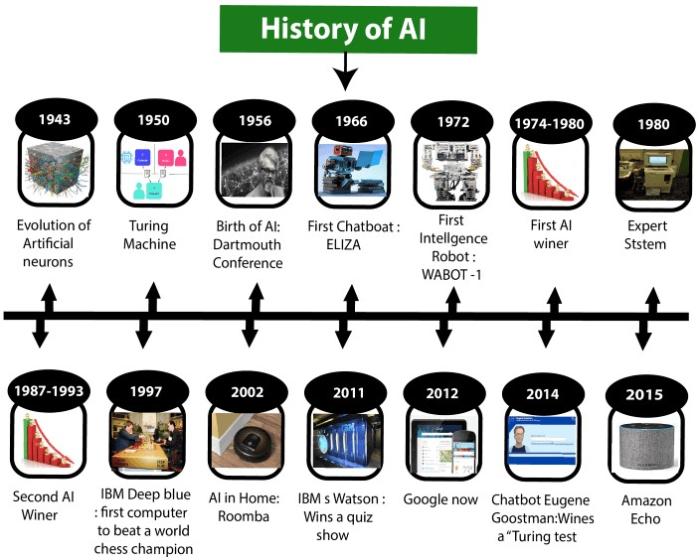
Figure 3.3 History of Artificial Intelligence (AI)
- Maturation of Artificial Intelligence (1943-1952)
  - The year 1943: The first work which is now recognized as AI was done by Warren McCulloch and Walter pits in 1943. They proposed a model of artificial neurons.
  - The year 1949: Donald Hebb demonstrated an updating rule for modifying the connection strength between neurons. His rule is now called Hebbian learning.
  - The year 1950: The Alan Turing who was an English mathematician and pioneered Machine learning in 1950. Alan Turing publishes "Computing Machinery and Intelligence" in which he proposed a test. The test can check the machine's ability to exhibit intelligent behavior equivalent to human intelligence, called a Turing test.
- The birth of Artificial Intelligence (1952-1956)
  - The year 1955: An Allen Newell and Herbert A. Simon created the "first artificial intelligence program" Which was named "Logic Theorist". This program had proved 38 of 52 Mathematics theorems, and find new and more elegant proofs for some theorems.
  - The year 1956: The word "Artificial Intelligence" first adopted by American Computer scientist John McCarthy at the Dartmouth Conference. For the first time, AI coined as an academic field. At that time high-level computer languages such as FORTRAN, LISP, or COBOL were invented. And the enthusiasm for AI was very high at that time. C. The golden years-Early enthusiasm (1956-1974)
  - The year 1966: The researchers emphasized developing algorithms that can solve mathematical problems. Joseph Weizenbaum created the first chatbot in 1966, which was named as ELIZA.
  - The year 1972: The first intelligent humanoid robot was built in Japan which was named WABOT-1.
- The first AI winter (1974-1980)
  - The duration between the years 1974 to 1980 was the first AI winter duration. AI winter refers to the time period where computer scientists dealt with a severe shortage of funding from the government for AI researches.
  - During AI winters, an interest in publicity on artificial intelligence was decreased.
- A boom of AI (1980-1987)
  - The year 1980: After AI winter duration, AI came back with "Expert System". Expert systems were programmed that emulate the decision-making ability of a human expert.
  - In the Year 1980, the first national conference of the American Association of Artificial Intelligence was held at Stanford University.
- The second AI winter (1987-1993)
  - The duration between the years 1987 to 1993 was the second AI Winter duration.
  - Again, Investors and government stopped in funding for AI research due to high cost but not efficient results. The expert system such as XCON was very cost-effective.
- The emergence of intelligent agents (1993-2011)
    - The year 1997: In the year 1997, IBM Deep Blue beats world chess champion, Gary Kasparov, and became the first computer to beat a world chess champion.
    - The year 2002: for the first time, AI entered the home in the form of Roomba, a vacuum cleaner.
    - The year 2006: AI came into the Business world until the year 2006. Companies like Facebook, Twitter, and Netflix also started using AI.
- Deep learning, big data and artificial general intelligence (2011-present)
      - The year 2011: In the year 2011, IBM's Watson won jeopardy, a quiz show, where it had to solve complex questions as well as riddles. Watson had proved that it could understand natural language and can solve tricky questions quickly.
      - The year 2012: Google has launched an Android app feature "Google now", which was able to provide information to the user as a prediction.
      - The year 2014: In the year 2014, Chatbot "Eugene Goostman" won a competition in the infamous "Turing test."
      - The year 2018: The "Project Debater" from IBM debated on complex topics with two master debaters and also performed extremely well.
      - Google has demonstrated an AI program "Duplex" which was a virtual assistant and which had taken hairdresser appointment on call, and the lady on the other side didn't notice that she was talking with the machine.
Now AI has developed to a remarkable level. The concept of Deep learning, big data, and data science are now trending like a boom. Nowadays companies like Google, Facebook, IBM, and Amazon are working with AI and creating amazing devices. The future of Artificial Intelligence is inspiring and will come with high intelligence.

3.3. Levels of AI
Stage 1 – Rule-Based Systems
The most common uses of AI today fit in this bracket, covering everything from business software (Robotic Process Automation) and domestic appliances to aircraft autopilots.
Stage 3 – Context Awareness and Retention
- Algorithms that develop information about the specific domain they are being applied in. They are trained on the knowledge and experience of the best humans, and their knowledge base can be updated as new situations and queries arise. Well, known applications of this level are chatbots and “roboadvisors”.
Stage 3 – Domain-Specific Expertise
- Going beyond the capability of humans, these systems build up expertise in a specific context taking in massive volumes of information which they can use for decision making. Successful use cases have been seen in cancer diagnosis and the well-known
Google Deepmind’s AlphaGo. Currently, this type is limited to one domain only would forget all it knows about that domain if you started to teach it something else.
Stage 4 – Reasoning Machines
- These algorithms have some ability to attribute mental states to themselves and others – they have a sense of beliefs, intentions, knowledge, and how their own logic works. This means they could reason or negotiate with humans and other machines. At the moment these algorithms are still in development, however, commercial applications are expected within the next few years.
Stage 5 – Self Aware Systems / Artificial General Intelligence (AGI)
- These systems have human-like intelligence – the most commonly portrayed AI in media – however, no such use is in evidence today. It is the goal of many working in AI and some believe it could be realized already from 2024.
Stage 6 – Artificial Superintelligence (ASI)
- AI algorithms can outsmart even the most intelligent humans in every domain. Logically it is difficult for humans to articulate what the capabilities might be, yet we would hope examples would include solving problems we have failed to so far, such as world hunger and dangerous environmental change. Views vary as to when and whether such a capability could even be possible, yet there a few experts who claim it can be realized by 2029. Fiction has tackled this idea for a long time, for example in the film Ex Machina or Terminator.
Stage 7 – Singularity and Transcendence
- This is the idea that development provided by ASI (Stage 6) leads to a massive expansion in human capability. Human augmentation could connect our brains to each other and to a future successor of the current internet, creating a “hive mind” that shares ideas, solves problems collectively, and even gives others access to our dreams as observers or participants. Pushing this idea further, we might go beyond the limits of the human body and connect to other forms of intelligence on the planet – animals, plants, weather systems, and the natural environment. Some proponents of singularity such as Ray Kurzweil, Google’s Director of Engineering, suggest we could see it happen by 2045 as a result of exponential rates of progress across a range of science and technology disciplines. The other side of the fence argues that singularity is impossible and human consciousness could never be digitized.
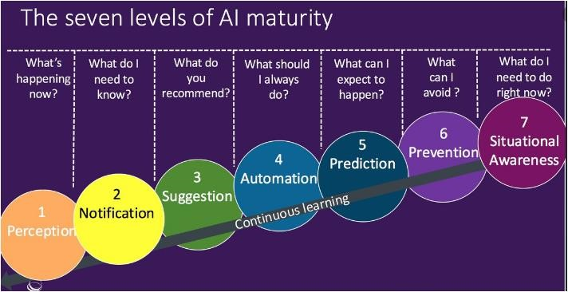
Figure 3.4 The seven layers of AI maturity

3.4. Types of AI
Artificial Intelligence can be divided into various types, there are mainly two types of the main categorization which are based on capabilities and based on functionally of AI, as shown in figure 3.5.
Following is the flow diagram which explains the types of AI.
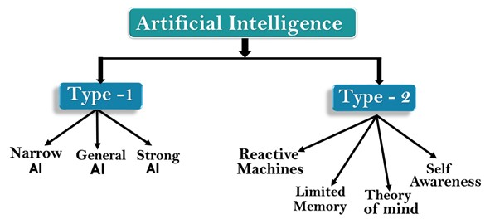
Figure 3.5 types of Artificial Intelligence (AI)

- Based on Capabilities
  - Weak AI or Narrow AI:
      - Narrow AI is a type of AI which is able to perform a dedicated task with intelligence. The most common and currently available AI is Narrow AI in the world of Artificial Intelligence.
      - Narrow AI cannot perform beyond its field or limitations, as it is only trained for one specific task. Hence it is also termed as weak AI. Narrow AI can fail in unpredictable ways if it goes beyond its limits.
      - Apple Siri is a good example of Narrow AI, but it operates with a limited predefined range of functions.
      - IBM's Watson supercomputer also comes under Narrow AI, as it uses an Expert system approach combined with Machine learning and natural language processing.
      - Some Examples of Narrow AI are Google translate, playing chess, purchasing suggestions on e-commerce sites, self-driving cars, speech recognition, and image recognition.
General AI:
      - General AI is a type of intelligence that could perform any intellectual task with efficiency like a human.
      - The idea behind the general AI to make such a system that could be smarter and think like a human on its own.
      - Currently, there is no such system exists which could come under general AI and can perform any task as perfect as a human. It may arrive within the next 20 or so years but it has challenges relating to hardware, the energy consumption required in today’s powerful machines, and the need to solve for catastrophic memory loss that affects even the most advanced deep learning algorithms of today
      - The worldwide researchers are now focused on developing machines with General AI.
      - As systems with general AI are still under research, and it will take lots of effort and time to develop such systems.
  - Super AI:
      - Super AI is a level of Intelligence of Systems at which machines could surpass human intelligence, and can perform any task better than a human with cognitive properties. This refers to aspects like general wisdom, problem solving and creativity. It is an outcome of general AI.
      - Some key characteristics of strong AI include capability include the ability to think, to reason solve the puzzle, make judgments, plan, learn, and communicate on its own.
      - Super AI is still a hypothetical concept of Artificial Intelligence. The development of such systems in real is still a world-changing task.
- Based on the functionality
  - Reactive Machines
      - Purely reactive machines are the most basic types of Artificial Intelligence.
      - Such AI systems do not store memories or past experiences for future actions.
      - These machines only focus on current scenarios and react on it as per possible best action.
      - IBM's Deep Blue system is an example of reactive machines.
      - Google's AlphaGo is also an example of reactive machines.
  - Limited Memory
      - Limited memory machines can store past experiences or some data for a short period of time.
      - These machines can use stored data for a limited time period only.
      - Self-driving cars are one of the best examples of Limited Memory systems. These cars can store the recent speed of nearby cars, the distance of other cars, speed limits, and other information to navigate the road.
  - Theory of Mind
      - Theory of Mind AI should understand human emotions, people, beliefs, and be able to interact socially like humans.
      - This type of AI machines is still not developed, but researchers are making lots of efforts and improvement for developing such AI machines.
  - Self-Awareness
      - Self-awareness AI is the future of Artificial Intelligence. These machines will be super intelligent and will have their own consciousness, sentiments, and selfawareness.
      - These machines will be smarter than the human mind.
      - Self-Awareness AI does not exist in reality still and it is a hypothetical concept.

3.4.1. How humans think
The goal of many researchers is to create strong and general AI that learns like a human and can solve general problems as the human brain does. Achieving this goal might require many more years.
How does a human being think? Intelligence or the cognitive process is composed of three main stages:
- Observe and input the information or data in the brain.
- Interpret and evaluate the input that is received from the surrounding environment.
- Make decisions as a reaction towards what you received as input and interpreted and evaluated.
AI researchers are simulating the same stages in building AI systems or models. This process represents the main three layers or components of AI systems.

3.4.2. Mapping human thinking to artificial intelligence components
Because AI is the science of simulating human thinking, it is possible to map the human thinking stages to the layers or components of AI systems.
In the first stage, humans acquire information from their surrounding environments through human senses, such as sight, hearing, smell, taste, and touch, through human organs, such as eyes, ears, and other sensing organs, for example, the hands.
In AI models, this stage is represented by the sensing layer, which perceives information from the surrounding environment. This information is specific to the AI application. For example, there are sensing agents such as voice recognition for sensing voice and visual imaging recognition for sensing images. Thus, these agents or sensors take the role of the hearing and sight senses in humans.
The second stage is related to interpreting and evaluating the input data. In AI, this stage is represented by the interpretation layer, that is, reasoning and thinking about the gathered input that is acquired by the sensing layer.
The third stage is related to taking action or making decisions. After evaluating the input data, the interacting layer performs the necessary tasks. Robotic movement control and speech generation are examples of functions that are implemented in the interacting layer.

3.5. Influencers of artificial intelligence
This section explores some of the reasons why AI is taking off now. The following influencers of AI are described in this section:
- Big data: Structured data versus unstructured data
- Advancements in computer processing speed and new chip architectures
- Cloud computing and APIs
- The emergence of data science

3.5.1. Big Data
Big data refers to huge amounts of data. Big data requires innovative forms of information processing to draw insights, automate processes, and help decision making. Big data can be structured data that corresponds to a formal pattern, such as traditional data sets and databases.
Also, big data includes semi-structured and unstructured formats, such as word-processing documents, videos, images, audio, presentations, social media interactions, streams, web pages, and many other kinds of content. Figure 3.6 depicts the rapid change of the data landscape.
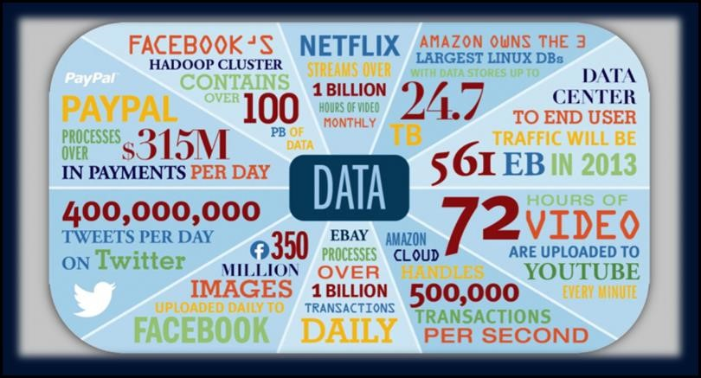
Figure 3.6 Current changes in the data landscape

3.5.1.1. Structured data versus unstructured data
Traditionally, computers primarily process structured data, that is, information with an organized structure, such as a relational database that is searchable by simple and straightforward search engine algorithms or SQL statements. But, real-world data such as the type that humans deal with constantly does not have a high degree of organization. For example, text that is written or spoken in natural language (the language that humans speak) does not constitute structured data. Unstructured data is not contained in a regular database and is growing exponentially, making up most of the data in the world. The exponential growth of unstructured data that is shown in Figure
3.7 below drives the need for a new kind of computer system.
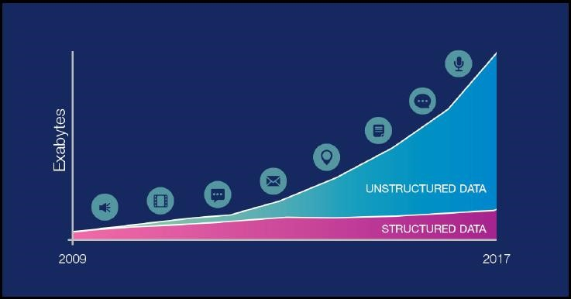
Figure 3.7 The comparison between the growth of structured and unstructured data
In the last few years, the availability of larger volumes and sources of data is enabling capabilities in AI that could not be used in the past due to lack of data availability, limited sample sizes, and an inability to analyze massive amounts of data in milliseconds.

3.5.1.2. Advancements in computer processing speed, new chip architectures, and big data file systems.
Significant advancements in computer processing and memory speeds enable us to make sense of the information that is generated by big data more quickly. In the past, statisticians and early data scientists were limited to working with sample data sets. In recent years, big data and the ability to process a large amount of data at high speeds have enabled researchers and developers to access and work with massive sets of data. Processing speeds and new computer chip architectures contribute to the rapid evolution of AI applications.
The meaning of big data expanded beyond the volume of data after the release of a paper by Google on MapReduce and the Google File System (GFS), which evolved into the Apache Hadoop opensource project. The Hadoop file system is a distributed file system that may run on a cluster of commodity machines, where the storage of data is distributed among the cluster and the processing is distributed too. This approach determines the speed with which data is processed. This approach includes an element of complexity with the introduction of new, structured, unstructured, and multi-structured data types. Large manufacturers of computer chips such as IBM and Intel are prototyping “brain-like” chips whose architecture is configured to mimic the biological brain’s network of neurons and the connections between them called synapses.

3.5.2. Cloud computing and application programming interfaces
Cloud computing is a general term that describes the delivery of on-demand services, usually through the internet, on a pay-per-use basis. Companies worldwide offer their services to customers over cloud platforms. These services might be data analysis, social media, video storage, e-commerce, and AI capabilities that are available through the internet and supported by cloud computing.
In general, application programming interfaces (APIs) expose capabilities and services. APIs enable software components to communicate with each other easily. The use of APIs as a method for integration injects a level of flexibility into the application lifecycle by making the task easier to connect and interface with other applications or services. APIs abstract the underlying workings of a service, application, or tool, and expose only what a developer needs, so programming becomes easier and faster. AI APIs are usually delivered on an open cloud-based platform on which developers can infuse AI capabilities into digital applications, products, and operations by using one or more of the available APIs.
All the significant companies in the AI services market deliver their services and tools on the internet through APIs over cloud platforms, for example:
- IBM delivers Watson AI services over IBM Cloud.
- Amazon AI services are delivered over Amazon Web Services (AWS).
- Microsoft AI tools are available over the MS Azure cloud.
- Google AI services are available in the Google Cloud Platform.
These services benefit from cloud platform capabilities, such as availability, scalability, accessibility, rapid deployment, flexible billing options, simpler operations, and management.

3.5.3. The emergence of data science
Data science has emerged in the last few years as a new profession that combines several disciplines, such as statistics, data analysis, machine learning, and others. The goal of data science is to extract knowledge or insights from data in various forms, either structured or unstructured, which is like data mining. After you collect a large enough volume of data, patterns emerge. Then, data scientists use learning algorithms on these patterns. Data science uses machine learning and AI to process big data.

3.6. Applications of AI
Artificial Intelligence has various applications in today's society. It is becoming essential for today's time because it can solve complex problems in an efficient way in multiple industries, such as Healthcare, entertainment, finance, education, etc. AI is making our daily life more comfortable and faster.
Following are some sectors which have the application of Artificial Intelligence:
- AI in agriculture
  - Agriculture is an area that requires various resources, labor, money, and time for the best result. Now a day's agriculture is becoming digital, and AI is emerging in this field. Agriculture is applying AI as agriculture robotics, solid and crop monitoring, predictive analysis. AI in agriculture can be very helpful for farmers.
- AI in Healthcare
  - In the last, five to ten years, AI becoming more advantageous for the healthcare industry and going to have a significant impact on this industry.
  - Healthcare Industries are applying AI to make a better and faster diagnosis than humans. AI can help doctors with diagnoses and can inform when patients are worsening so that medical help can reach the patient before hospitalization.
- AI in education:
  - AI can automate grading so that the tutor can have more time to teach. AI chatbot can communicate with students as a teaching assistant.
  - AI in the future can be work as a personal virtual tutor for students, which will be accessible easily at any time and any place.
- AI in Finance and E-commerce
  - AI and finance industries are the best matches for each other. The finance industry is implementing automation, chatbot, adaptive intelligence, algorithm trading, and machine learning into financial processes.
  - AI is providing a competitive edge to the e-commerce industry, and it is becoming more demanding in the e-commerce business. AI is helping shoppers to discover associated products with recommended size, color, or even brand.
- AI in Gaming
  - AI can be used for gaming purposes. The AI machines can play strategic games like chess, where the machine needs to think of a large number of possible places.
- AI in Data Security
  - The security of data is crucial for every company and cyber-attacks are growing very rapidly in the digital world. AI can be used to make your data more safe and secure. Some examples such as AEG bot, AI2 Platform, are used to determine software bugs and cyber-attacks in a better way.
- AI in Social Media
  - Social Media sites such as Facebook, Twitter, and Snapchat contain billions of user profiles, which need to be stored and managed in a very efficient way. AI can organize and manage massive amounts of data. AI can analyze lots of data to identify the latest trends, hashtags, and requirements of different users.
- AI in Travel &Transport
  - AI is becoming highly demanding for travel industries. AI is capable of doing various travel related works such as from making travel arrangements to suggesting the hotels, flights, and best routes to the customers. Travel industries are using AIpowered chatbots which can make human-like interaction with customers for a better and fast response.
- AI in the Automotive Industry
    - Some Automotive industries are using AI to provide virtual assistants to their use for better performance. Such as Tesla has introduced TeslaBot, an intelligent virtual assistant.
    - Various Industries are currently working for developing self-driven cars which can make your journey more safe and secure.
- AI in Robotics:
    - Artificial Intelligence has a remarkable role in Robotics. Usually, general robots are programmed such that they can perform some repetitive task, but with the help of AI, we can create intelligent robots which can perform tasks with their own experiences without pre-programmed.
    - Humanoid Robots are the best examples for AI in robotics, recently the intelligent Humanoid robot named Erica and Sophia has been developed which can talk and behave like humans.
- AI in Entertainment
➢ We are currently using some AI-based applications in our daily life with some entertainment services such as Netflix or Amazon. With the help of ML/AI algorithms, these services show the recommendations for programs or shows.

3.7. AI tools and platforms
The business has workflows that are repetitive, tedious and difficult which tend to slow down production and also increases the cost of operation. To bring down the costs of operation, businesses have no option rather than automate some of the functions to cut down the cost of production. By digitizing repetitive tasks, an enterprise can cut costs on paperwork and labor which further eliminates human error thus boosting efficiency leading to better results. For a business to gain from the above benefits, they must choose the right automation tools otherwise it will all be in vain. Automating processes involving employing artificial intelligence platforms that can support the digitalization process and deliver the same or better results than human beings would have achieved.
AI platforms are defined as some sort of hardware architecture or software framework (including application frameworks), that allows the software to run. It involves the use of machines to perform the tasks that are performed by human beings. The platform simulates the cognitive function that human minds perform such as problem-solving, learning, reasoning, social intelligence as well as general intelligence.
Artificial intelligence (AI) platforms provide users a tool kit to build intelligent applications. These platforms combine intelligent, decision-making algorithms with data, which enables developers to create a business solution. Some platforms offer pre-built algorithms and simplistic workflows with such features as drag-and-drop modeling and visual interfaces that easily connect necessary data to the end solution, while others require a greater knowledge of development and coding. These algorithms can include functionality for image recognition (It gives the machine the ability to identify an image which is helpful in police stations to recognize a criminal), natural language processing (It gives machines the ability to read and understand human language. Some straightforward applications of natural language processing include information retrieval, text mining, question answering, and machine translation.), voice recognition (It gives the machine the ability to differentiate the voice of a person), recommendation systems, and predictive analytics (It gives the machine to predict the question and prepare the answer, in online marketing platforms this will predict the items you may buy), in addition to other machine learning capabilities.
AI platforms are frequently used by developers to create both the learning algorithm and intelligent application. However, users without intensive development skills will benefit from the platforms’ pre-built algorithms and other features that curb the learning curve. AI platforms are very similar to Platforms as a Service (PaaS), which allows for basic application development, but these products differ by offering machine learning options. As intelligent applications become the norm, it may become commonplace for all PaaS products to begin to provide the same machine learning options as AI Platforms.

Many tools are used in AI, including versions of search and mathematical optimization, logic, methods based on probability and economics.
AI has developed a large number of tools to solve the most difficult problems in computer science, like:
- Search and optimization
- Logic
- Probabilistic methods for uncertain reasoning
- Classifiers and statistical learning methods
- Neural networks
- Control theory
- Languages
The most common artificial intelligence platforms include Microsoft AZURE Machine Learning, Google Cloud Prediction API, IBM Watson, TensorFlow, Infosys Nia, Wipro HOLMES, API.AI, Premonition, Rainbird, Ayasdi, MindMeld, and Meya.

3.8. Semple AI application
- Commuting
  - Google’s AI-Powered Predictions
  - Ridesharing Apps Like Uber and Lyft
  - Commercial Flights Use an AI Autopilot
- Email
  - Spam Filters
  - Smart Email Categorization
- Social Networking
  - Facebook - When you upload photos to Facebook, the service automatically highlights faces and suggests friends tag.
  - Pinterest - Pinterest uses computer vision, an application of AI where computers are taught to “see,” in order to automatically identify objects in images (or “pins”) and then recommend visually similar pins. Other applications of machine learning at Pinterest includes spam prevention, search, and discovery, ad performance and monetization, and email marketing.
  - Instagram - Instagram, which Facebook acquired in 2012, uses machine learning to identify the contextual meaning of emoji, which have been steadily replacing slang
(for instance, a laughing emoji could replace “lol”)
  - Snapchat - Snapchat introduced facial filters, called Lenses, in 2015. These filters track facial movements, allowing users to add animated effects or digital masks that adjust when their faces moved.
- Online Shopping
  - Search - Your Amazon searches (“ironing board”, “pizza stone”, “Android
charger”, etc.) quickly return a list of the most relevant products related to your search
  - Recommendations - You see recommendations for products you’re interested in as “customers who viewed this item also viewed” and “customers who bought this item also bought”, as well as via personalized recommendations on the home page, bottom of item pages, and through email. Amazon uses artificial neural networks to generate these product recommendations.
- Mobile Use
  - Voice-to-Text - A standard feature on smartphones today is voice-to-text. By pressing a button or saying a particular phrase (“Ok Google”, for example), you can start speaking and your phone converts the audio into text
  - Smart Personal Assistants - Now that voice-to-text technology is accurate enough to rely on for basic conversation, it has become the control interface for a new generation of smart personal assistants.
    - Siri and Google Now (now succeeded by the more sophisticated Google Assistant), which could perform internet searches, set reminders, and integrate with your calendar.
    - Amazon expanded upon this model with the announcement of complementary hardware and software components:
    - Alexa, an AI-powered personal assistant that accepts voice commands to create to-do lists, order items online, set reminders, and answer questions
(via internet searches) o Echo (and later, Dot) smart speakers that allow you to integrate Alexa into your living room and use voice commands to ask natural language questions, play music, order pizza, hail an Uber, and integrate with smart home devices.
  - Microsoft has followed suit with Cortana, its own AI assistant that comes preloaded on Windows computers and Microsoft smartphones.

Chapter 4: Internet of Things (IoT)

Introduction
In the previous, you learned about the basics of Artificial Intelligence. In this chapter, you will learn about the overview of the Internet of Things (IoT), how it works, IoT tools and platforms, and sample applications of IoT.
After accomplishing this chapter, Students will be able to:
- Describe IoT
- Explain the history of IoT
- Describe the pros and cons of IoT
- Explain how IoT works
- Explain the architecture of IoT
- Describe IoT tools and platforms
- Describe some of the application areas of IoT

4.1. Overview of IoT
The most important features of IoT include artificial intelligence, connectivity, sensors, active engagement, and small device use. A brief review of these features is given below −
- AI − IoT essentially makes virtually anything “smart”, meaning it enhances every aspect of life with the power of data collection, artificial intelligence algorithms, and networks. This can mean something as simple as enhancing your refrigerator and cabinets to detect when milk and your favorite cereal run low, and to then place an order with your preferred grocer.
- Connectivity − New enabling technologies for networking and specifically IoT networking, mean networks are no longer exclusively tied to major providers. Networks can exist on a much smaller and cheaper scale while still being practical. IoT creates these small networks between its system devices.
- Sensors − IoT loses its distinction without sensors. They act as defining instruments that transform IoT from a standard passive network of devices into an active system capable of real-world integration.
- Active Engagement − Much of today's interaction with connected technology happens through passive engagement. IoT introduces a new paradigm for active content, product, or service engagement.
Small Devices − Devices, as predicted, have become smaller, cheaper, and more powerful over time. IoT exploits purpose-built small devices to deliver its precision, scalability, and versatility.

4.1.1. What is IoT?
The description of the Internet of Things is related to different definitions used by several groups for promoting the particular concept in the whole world.
- According to the Internet Architecture Board’s (IAB) definition, IoT is the networking of smart objects, meaning a huge number of devices intelligently communicating in the presence of internet protocol that cannot be directly operated by human beings but exist as components in buildings, vehicles or the environment.
- According to the Internet Engineering Task Force (IETF) organization’s definition, IoT is the networking of smart objects in which smart objects have some constraints such as limited bandwidth, power, and processing accessibility for achieving interoperability among smart objects.
- According to the IEEE Communications category magazine’s definition, IoT is a framework of all things that have a representation in the presence of the internet in such a way that new applications and services enable the interaction in the physical and virtual world in the form of Machine-to-Machine (M2M) communication in the cloud.
- According to the Oxford dictionary’s definition, IoT is the interaction of everyday object’s computing devices through the Internet that enables the sending and receiving of useful data.
- The term Internet of Things (IoT) according to the 2020 conceptual framework is expressed through a simple formula such as:
IoT= Services+ Data+ Networks + Sensors
Generally, The Internet of Things (IoT) is the network of physical objects or "things" embedded with electronics, software, sensors, and network connectivity, which enables these objects to collect and exchange data. IoT is a system of interrelated computing devices, mechanical and digital machines, objects, animals or people that are provided with unique identifiers and the ability to transfer data over a network without requiring human-to-human or human-to-computer interaction. IoT is a network of devices that can sense, accumulate and transfer data over the internet without any human intervention.
Simply stated, the Internet of Things consists of any device with an on/off switch connected to the Internet. This includes almost anything you can think of, ranging from cellphones to building maintenance to the jet engine of an airplane. Medical devices, such as a heart monitor implant or a biochip transponder in a farm animal, can transfer data over a network and are members of the IoT. If it has an off/on the switch, then it can, theoretically, be part of the system. The IoT consists of a gigantic network of internet-connected “things” and devices. Ring, a doorbell that links to your smartphone, provides an excellent example of a recent addition to the Internet of Things. Ring signals you when the doorbell is pressed and lets you see who it is and to speak with them.
The internet of things (IoT) has found its application in several areas such as connected industry, smart-city, smart-home, smart-energy, connected car, smart agriculture, connected building and campus, health care, logistics, among other domains (see Figure 4.1). IoT systems allow users to achieve deeper automation, analysis, and integration within a system. They improve the reach of these areas and their accuracy.
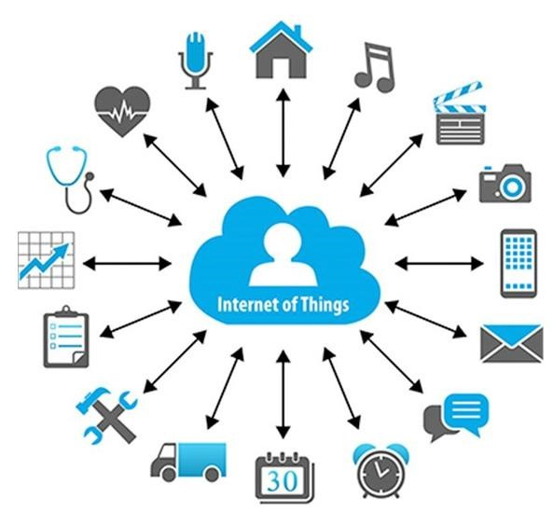
Figure 4.1 IoT in Different Domains
IoT utilizes existing and emerging technology for sensing, networking, and robotics. IoT exploits recent advances in software, falling hardware prices, and modern attitudes towards technology. Its new and advanced elements bring major changes in the delivery of products, goods, and services; and the social, economic, and political impact of those changes.

4.1.2. History of IoT
The Internet of Things has not been around for very long. However, there have been visions of machines communicating with one another since the early 1800s. Machines have been providing direct communications since the telegraph (the first landline) was developed in the 1830s and
1840s. Described as “wireless telegraphy,” the first radio voice transmission took place on June 3, 1900, providing another necessary component for developing the Internet of Things. The development of computers began in the 1950s.
The Internet, itself a significant component of the IoT, started out as part of DARPA (Defense Advanced Research Projects Agency) in 1962 and evolved into ARPANET in 1969. In the 1980s, commercial service providers began supporting public use of ARPANET, allowing it to evolve into our modern Internet. Global Positioning Satellites (GPS) became a reality in early 1993, with the Department of Defense providing a stable, highly functional system of 24 satellites. This was quickly followed by privately owned, commercial satellites being placed in orbit. Satellites and landlines provide basic communications for much of the IoT. One additional and important component in developing a functional IoT was IPV6’s remarkably intelligent decision to increase address space.
The Internet of Things, as a concept, wasn’t officially named until 1999. One of the first examples of an Internet of Things is from the early 1980s and was a Coca Cola machine, located at the Carnegie Melon University. Local programmers would connect by the Internet to the refrigerated appliance, and check to see if there was a drink available and if it was cold, before making the trip.
By the year 2013, the Internet of Things had evolved into a system using multiple technologies, ranging from the Internet to wireless communication and from micro-electromechanical systems (MEMS) to embedded systems. The traditional fields of automation (including the automation of buildings and homes), wireless sensor networks, GPS, control systems, and others, all support the IoT.
Kevin Ashton, the Executive Director of Auto-ID Labs at MIT, was the first to describe the Internet of Things, during his 1999 speech. Kevin Ashton stated that Radio Frequency Identification (RFID) was a prerequisite for the Internet of Things. He concluded if all devices were “tagged,” computers could manage, track, and inventory them. To some extent, the tagging of things has been achieved through technologies such as digital watermarking, barcodes, and QR codes.
Inventory control is one of the more obvious advantages of the Internet of Things.

4.1.3. IoT − Advantages
The advantages of IoT span across every area of lifestyle and business. Here is a list of some of the advantages that IoT has to offer:
- Improved Customer Engagement − Current analytics suffer from blind-spots and significant flaws inaccuracy; and as noted, engagement remains passive. IoT completely transforms this to achieve richer and more effective engagement with audiences.
- Technology Optimization − The same technologies and data which improve the customer experience also improve device use, and aid in more potent improvements to technology.
IoT unlocks a world of critical functional and field data.
- Reduced Waste − IoT makes areas of improvement clear. Current analytics give us superficial insight, but IoT provides real-world information leading to the more effective management of resources.
- Enhanced Data Collection − Modern data collection suffers from its limitations and its design for passive use. IoT breaks it out of those spaces and places it exactly where humans really want to go to analyze our world. It allows an accurate picture of everything.

4.1.4. IoT – Disadvantages
Here is a list of some of the disadvantages of IoT. these are:
- As the number of connected devices increases and more information is shared between devices, the potential that a hacker could steal confidential information also increases.
- If there’s a bug in the system, it’s likely that every connected device will become corrupted.
- Since there’s no international standard of compatibility for IoT, it’s difficult for devices from different manufacturers to communicate with each other.
- Enterprises may eventually have to deal with massive numbers maybe even millions of IoT devices and collecting and managing the data from all those devices will be challenging.

4.1.5. Challenges of IoT
Though IoT delivers an impressive set of advantages, it also presents a significant set of challenges. Here is a list of some its major issues:
- Security − IoT creates an ecosystem of constantly connected devices communicating over networks. The system offers little control despite any security measures. This leaves users exposed to various kinds of attackers.
- Privacy − The sophistication of IoT provides substantial personal data in extreme detail without the user's active participation.
- Complexity − Some find IoT systems complicated in terms of design, deployment, and maintenance given their use of multiple technologies and a large set of new enabling technologies.
- Flexibility − Many are concerned about the flexibility of an IoT system to integrate easily with another. They worry about finding themselves with several conflicting or locking systems.
- Compliance − IoT, like any other technology in the realm of business, must comply with regulations. Its complexity makes the issue of compliance seem incredibly challenging when many consider standard software compliance a battle.

4.2. How does it work?
An IoT ecosystem consists of web-enabled smart devices that use embedded processors, sensors and communication hardware to collect, send and act on data they acquire from their environments. IoT devices share the sensor data they collect by connecting to an IoT gateway or another edge device where data is either sent to the cloud to be analyzed or analyzed locally. Sometimes, these devices communicate with other related devices and act on the information they get from one another. The devices do most of the work without human intervention, although people can interact with the devices. For instance, to set them up, give them instructions or access the data. The connectivity, networking and communication protocols used with these web-enabled devices largely depend on the specific IoT applications deployed.

4.2.1. Architecture of IoT
In general, an IoT device can be explained as a network of things that consists of hardware, software, network connectivity, and sensors. Hence, the architecture of IoT devices comprises four major components: sensing, network, data processing, and application layers (as depicted in Figure
4.2). A detailed description of these layers is given below.
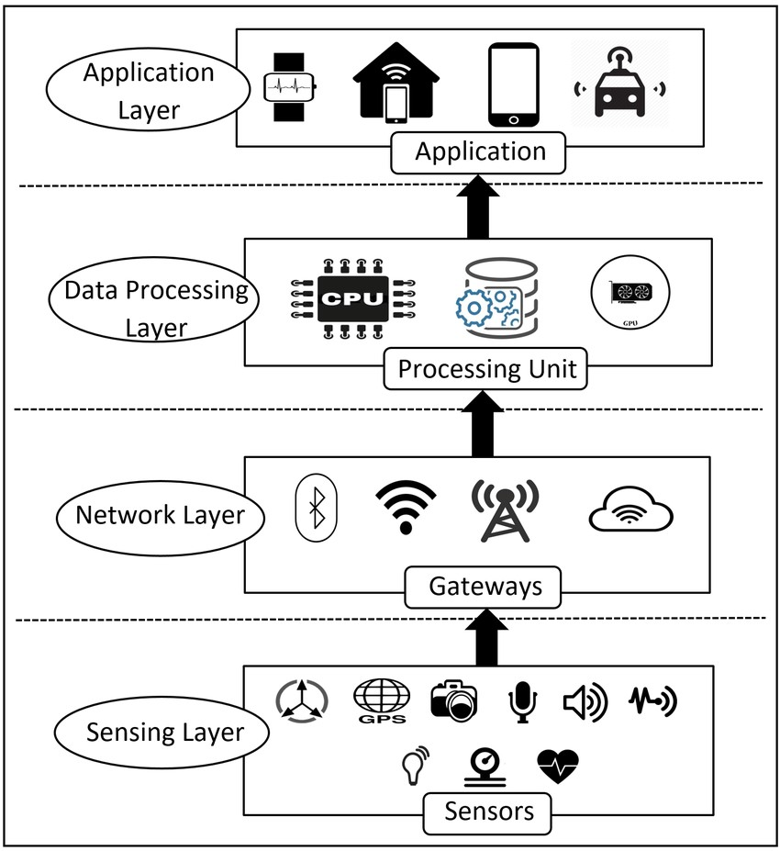
- Sensing Layer - The main purpose of the sensing layer is to identify any phenomena in the devices’ peripheral and obtain data from the real world. This layer consists of several sensors. Using multiple sensors for applications is one of the primary features of IoT devices. Sensors in IoT devices are usually integrated through sensor hubs. A sensor hub is a common connection point for multiple sensors that accumulate and forward sensor data to the processing unit of a device. Actuators can also intervene to change the physical conditions that generate
Figure 4.2 Architecture of IoT
the data. An actuator might, for
example, shut off a power supply, adjust an airflow valve, or move a robotic gripper in an assembly process. Sensors in IoT devices can be classified into three broad categories as described below:
  - Motion Sensors: Motion sensors measure the change in motion as well as the orientation of the devices. There are two types of motions one can observe in a device: linear and angular motions. The linear motion refers to the linear displacement of an IoT device while the angular motion refers to the rotational displacement of the device.
  - Environmental Sensors: Sensors such as Light sensors, Pressure sensors, etc. are embedded in IoT devices to sense the change in environmental parameters in the device’s peripheral. The primary purpose of using environmental sensors in IoT devices is to help the devices to take autonomous decisions according to the changes of a device’s peripheral. For instance, environment sensors are used in many applications to improve user experience (e.g., home automation systems, smart locks, smart lights, etc.).
  - Position sensors: Position sensors of IoT devices deal with the physical position and location of the device. The most common position sensors used in IoT devices are magnetic sensors and Global Positioning System (GPS) sensors. Magnetic sensors are usually used as digital compass and help to fix the orientation of the device display. On the other hand, GPS is used for navigation purposes in IoT devices.
- Network Layer - The network layer acts as a communication channel to transfer data, collected in the sensing layer, to other connected devices. In IoT devices, the network layer is implemented by using diverse communication technologies (e.g., Wi-Fi, Bluetooth, Zigbee, ZWave, LoRa, cellular network, etc.) to allow data flow between other devices within the same network.
- Data Processing Layer - The data processing layer consists of the main data processing unit of IoT devices. The data processing layer takes data collected in the sensing layer and analyses the data to make decisions based on the result. In some IoT devices (e.g., smartwatch, smart home hub, etc.), the data processing layer also saves the result of the previous analysis to improve the user experience. This layer may share the result of data processing with other connected devices via the network layer.
- Application Layer - The application layer implements and presents the results of the data processing layer to accomplish disparate applications of IoT devices. The application layer is a user-centric layer that executes various tasks for the users. There exist diverse IoT applications, which include smart transportation, smart home, personal care, healthcare, etc.

4.2.2. Devices and Networks
Connected devices are part of a scenario in which every device talks to other related devices in an environment to automate home and industrial tasks, and to communicate usable sensor data to users, businesses and other interested parties. IoT devices are meant to work in concert for people at home, in industry or in the enterprise. As such, the devices can be categorized into three main groups: consumer, enterprise and industrial.
Consumer connected devices include smart TVs, smart speakers, toys, wearables, and smart appliances. smart meters, commercial security systems and smart city technologies such as those used to monitor traffic and weather conditions are examples of industrial and enterprise IoT devices. Other technologies, including smart air conditioning, smart thermostats, smart lighting, and smart security, span home, enterprise, and industrial uses. In the enterprise, smart sensors located in a conference room can help an employee locate and schedule an available room for a meeting, ensuring the proper room type, size and features are available. When meeting attendees enter the room, the temperature will adjust according to the occupancy, and the lights will dim as the appropriate PowerPoint loads on the screen and the speaker begins his presentation.
IoT network typically includes a number of devices with constrained resources (power, processing, memory, among others) and some of those devices may be massively deployed over large areas like smart cities, industrial plants, whereas others may be deployed in hard-to-reach areas like pipelines hazardous zones, or even in hostile environments like war zones. Therefore, the efficient management of IoT networks requires considering both the constraints of low power IoT devices and the deployment complexity of the underlying communication infrastructure. IoT landscape is depicted by an increasing number of connected devices characterized by their heterogeneity and the presence of resources constrained networks. To ensure the correct functioning of those connected devices, they must be remotely accessed to configure, monitoring their status, and so forth. Traditional management solutions cannot be used for low power devices networks given their resources limitation and scalability issues. Therefore, efficient and autonomic management of IoT networks is needed. Developing an IoT network management solution is not an easy task because of the intrinsic constraints of IoT networks (architecture, technologies, physical layer).
Indeed, it is necessary to take into account several elements such as scalability, interoperability, energy efficiency, topology control, Quality of Service (QoS), fault tolerance, and security. The security, context-aware, and the standard model of messages still in an early stage and should be resolved in a new management platform. Therefore, this work proposes a platform for IoT networks and devices management, called M4DN.IoT (Management for Device and Network in the Internet of Things). This solution integrates and controls the individual functionalities of the devices in an IoT network as well as the status and characteristics of this network. M4DN. IoT defines a management structure in two scopes: local management, where the platform runs in the same environment as the devices, and remote management, where the platform controls the devices in different networks.
The structure of the platform is expandable, allowing the addition of new types of network devices or applications. In addition, the platform provides standard web services, such as device discovery, data storage, and user authorities, which are basic requirements for creating IoT applications.

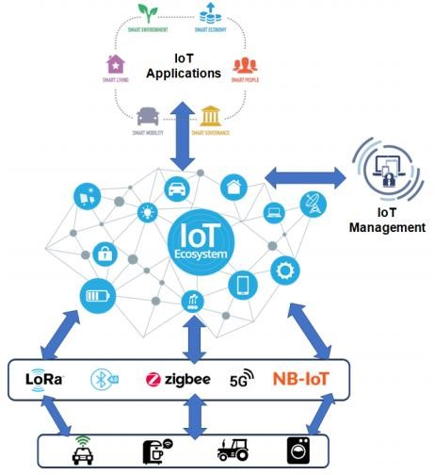
Figure 4.3 Networked IoT Devices

4.3. IoT Tools and Platforms
There are many vendors in the industrial IoT platform marketplace, offering remarkably similar capabilities and methods of deployment. These IoT Platform Solutions are based on the Internet of Things and cloud technology. They can be used in areas of smart home, city, enterprise, home automation, healthcare or automotive, just to name a few.
IoT Platform | Key features
KAA | - Manage an unlimited number of connected devices  - Set up cross-device interoperability  - Perform real-time device monitoring  - Perform remote device provisioning and configuration  - Collect and analyze sensor data  - Analyze user behavior and deliver targeted notifications  - Create cloud services for smart products
Site Where | - Run any number of IoT applications on a single SiteWhere instance  - Spring delivers the core configuration framework  - Add devices through self-registration  - Integrates with third-party integration frameworks such as Mule any point  - Default database storage is MongoDB  - Eclipse Californium for CoAP messaging  - InfluxDB for event data storage  - Grafana to visualize SiteWhere data
Thing Speak | - Collect data in private channels  - Share data with public channels  - MATLAB analytics and visualizations  - Alerts  - Event scheduling  - App integrations  - Worldwide community
Device Hive | - Directly integrate with Alexa  - Visualization dashboard of your choice  - It supports Big data solutions such as ElasticSearch, Apache Spark, Cassandra and Kafka for real-time and batch processing.  - Connect any device  - It comes with Apache Spark and Spark Streaming support.  - Supports libraries written in various programming languages, including Android and iOS libraries  - It allows running batch analytics and machine learning on top of your device data
Zetta | - Supports a wide range of hacker boards  - Zetta allows you to assemble smartphone apps, device apps, and cloud apps
Things Board | - Real-time data visualization and remote device control  - Customizable rules, plugins, widgets and transport implementations
- Allows monitoring client-side and provision server-side device attributes.
- Support multi-tenant installations out-of-the-box.
- Supports transport encryption for both MQTT and HTTP(s) protocols.

4.4. Applications of IoT
The versatile nature of IoT makes it an attractive option for so many businesses, organizations, and government branches, that it doesn’t make sense to ignore it. Here’s a sample of various industries, and how IoT can be best applied.
- Agriculture - For indoor planting, IoT makes monitoring and management of microclimate conditions a reality, which in turn increases production. For outside planting, devices using IoT technology can sense soil moisture and nutrients, in conjunction with weather data, better control smart irrigation and fertilizer systems. If the sprinkler systems dispense water only when needed, for example, this prevents wasting a precious resource.
- Consumer Use - For private citizens, IoT devices in the form of wearables and smart homes make life easier. Wearables cover accessories such as Fitbit, smartphones, Apple watches, health monitors, to name a few. These devices improve entertainment, network connectivity, health, and fitness. Smart homes take care of things like activating environmental controls so that your house is at peak comfort when you come home. Dinner that requires either an oven or a crockpot can be started remotely, so the food is ready when you arrive. Security is made more accessible as well, with the consumer having the ability
to control appliances and lights remotely, as well as activating a smart lock to allow the appropriate people to enter the house even if they don’t have a key.
- Healthcare - First and foremost, wearable IoT devices let hospitals monitor their patients’ health at home, thereby reducing hospital stays while still providing up to the minute realtime information that could save lives. In hospitals, smart beds keep the staff informed as to the availability, thereby cutting wait time for free space. Putting IoT sensors on critical equipment means fewer breakdowns and increased reliability, which can mean the difference between life and death. Elderly care becomes significantly more comfortable with IoT. In addition to the above-mentioned real-time home monitoring, sensors can also determine if a patient has fallen or is suffering a heart attack.
- Insurance - Even the insurance industry can benefit from the IoT revolution. Insurance companies can offer their policyholders discounts for IoT wearables such as Fitbit. By employing fitness tracking, the insurer can offer customized policies and encourage healthier habits, which in the long run benefits everyone, insurer, and customer alike.
- Manufacturing - The world of manufacturing and industrial automation is another big winner in the IoT sweepstakes. RFID and GPS technology can help a manufacturer track a product from its start on the factory floor to its placement in the destination store, the whole supply chain from start to finish. These sensors can gather information on travel time, product condition, and environmental conditions that the product was subjected to. Sensors attached to factory equipment can help identify bottlenecks in the production line, thereby reducing lost time and waste. Other sensors mounted on those same machines can also track the performance of the machine, predicting when the unit will require maintenance, thereby preventing costly breakdowns.
- Retail - IoT technology has a lot to offer the world of retail. Online and in-store shopping sales figures can control warehouse automation and robotics, information gleaned from IoT sensors. Much of this relies on RFIDs, which are already in heavy use worldwide. Mall locations are iffy things; business tends to fluctuate, and the advent of online shopping has driven down the demand for brick and mortar establishments. However, IoT can help analyze mall traffic so that stores located in malls can make the necessary adjustments that enhance the customer’s shopping experience while reducing overhead. Speaking of customer engagement, IoT helps retailers target customers based on past purchases.
Equipped with the information provided through IoT, a retailer could craft a personalized promotion for their loyal customers, thereby eliminating the need for costly mass marketing promotions that don’t stand as much of a chance of success. Much of these promotions can be conducted through the customers’ smartphones, especially if they have an app for the appropriate store.
- Transportation - By this time, most people have heard about the progress being made with self-driving cars. But that’s just one bit of the vast potential in the field of transportation. The GPS, which if you think of it is another example of IoT, is being utilized to help transportation companies plot faster and more efficient routes for trucks hauling freight, thereby speeding up delivery times. There’s already significant progress made in navigation, once again alluding to a phone or car’s GPS. But city planners can also use that data to help determine traffic patterns, parking space demand, and road construction and maintenance.
- Utilities - IoT sensors can be employed to monitor environmental conditions such as humidity, temperature, and lighting. The information provided by IoT sensors can aid in the creation of algorithms that regulate energy usage and make the appropriate adjustments, eliminating the human equation (and let’s face it, who of us hasn’t forgotten to switch off lights in a room or turn down the thermostat?). With IoT-driven environmental control, businesses and private residences can experience significant energy savings, which in the long run, benefits everyone, including the environment! On a larger scale, data gathered by the Internet of Things can be used to help run municipal power grids more efficiently, analyzing factors such as usage. In addition, the sensors can help pinpoint outages faster, thereby increasing the response time of repair crews and decreasing blackout times.

4.3.1. IoT Based Smart Home
Smart Home initiative allows subscribers to remotely manage and monitor different home devices from anywhere via smartphones or over the web with no physical distance limitations. With the ongoing development of mass-deployed broadband internet connectivity and wireless technology, the concept of a Smart Home has become a reality where all devices are integrated and interconnected via the wireless network. These “smart” devices have the potential to share information with each other given the permanent availability to access the broadband internet connection.
- Remote Control Appliances: Switching on and off remotely appliances to avoid accidents and save energy.
- Weather: Displays outdoor weather conditions such as humidity, temperature, pressure, wind speed and rain levels with the ability to transmit data over long distances.
- Smart Home Appliances: Refrigerators with LCD screen telling what’s inside, food that’s about to expire, ingredients you need to buy and with all the information available on a smartphone app. Washing machines allowing you to monitor the laundry remotely, and. The kitchen ranges with the interface to a Smartphone app allowing remotely adjustable temperature control and monitoring the oven’s self-cleaning feature.
- Safety Monitoring: cameras, and home alarm systems making people feel safe in their daily life at home.
- Intrusion Detection Systems: Detection of window and door openings and violations to prevent intruders.
- Energy and Water Use: Energy and water supply consumption monitoring to obtain advice on how to save cost and resources, & many more.

4.3.2. IoT Based Smart City
In cities, the development of smart grids, data analytics, and autonomous vehicles will provide an intelligent platform to deliver innovations in energy management, traffic management, and security, sharing the benefits of this technology throughout society.
- Structural Health: Monitoring of vibrations and material conditions in buildings, bridges and historical monuments.
- Lightning: intelligent and weather adaptive lighting in street lights.
- Safety: Digital video monitoring, fire control management, public announcement systems.
- Transportation: Smart Roads and Intelligent High-ways with warning messages and diversions according to climate conditions and unexpected events like accidents or traffic jams.
- Smart Parking: Real-time monitoring of parking spaces available in the city making residents able to identify and reserve the closest available spaces,
- Waste Management: Detection of rubbish levels in containers to optimize the trash collection routes. Garbage cans and recycle bins with RFID tags allow the sanitation staff to see when garbage has been put out.

4.3.3. IoT Based Smart Farming
- Green Houses: Control micro-climate conditions to maximize the production of fruits and vegetables and its quality.
- Compost: Control of humidity and temperature levels in alfalfa, hay, straw, etc. to prevent fungus and other microbial contaminants.
- Animal Farming/Tracking: Location and identification of animals grazing in open pastures or location in big stables, Study of ventilation and air quality in farms and detection of harmful gases from excrements.
- Offspring Care: Control of growing conditions of the offspring in animal farms to ensure its survival and health.
- Field Monitoring: Reducing spoilage and crop waste with better monitoring, accurate ongoing data obtaining, and management of the agriculture fields, including better control of fertilizing, electricity and watering.

Chapter 5: Augmented Reality (AR)

Introduction
In the previous chapter, you learned about the basics of the Internet of things (IoT). In this chapter, we will take a closer look at the overview of augmented reality, the difference between virtual reality (VR), augmented reality (AR) and mixed reality (MR), architecture of AR systems, and its application of AR systems such as in education, medicine, entertainment, etc. are discussed.
After accomplishing this chapter, Students will be able to:
- Explain augmented reality
- Explain the features of augmented reality
- Explain the difference between AR, VR, and MR
- Explain the architecture of augmented reality systems
- Describe the application areas of augmented reality

5.1. Overview of augmented reality
The fundamental idea of AR is to combine, or mix, the view of the real environment with additional, virtual content that is presented through computer graphics. Its convincing effect is achieved by ensuring that the virtual content is aligned and registered with the real objects. As a person moves in an environment and their perspective view of real objects changes, the virtual content should also be presented from the same perspective
Augmented reality (AR) is a form of emerging technology that allows users to overlay computer generated content in the real world. AR refers to a live view of a physical real-world environment whose elements are merged with augmented computer-generated images creating a mixed reality. The augmentation is typically done in real-time and in semantic context with environmental elements. By using the latest AR techniques and technologies, the information about the surrounding real world becomes interactive and digitally usable. Through this augmented vision, a user can digitally interact with and adjust information about their surrounding environment.
Augmented Reality (AR) as a real-time direct or indirect view of a physical real-world environment that has been enhanced/augmented by adding virtual computer-generated information to it.
Augmented reality is the integration of digital information with the user's environment in realtime. Unlike virtual reality, which creates a totally artificial environment, augmented reality uses the existing environment and overlays new information on top of it. A live direct or indirect view of a physical, real-world environment whose elements are augmented by computer-generated sensory input such as sound, video, graphics or GPS data.

5.2. Virtual reality (VR), Augmented Reality (AR) vs Mixed reality (MR)
With constant development in computer vision and the exponential advancement of computer processing power, virtual reality (VR), augmented reality (AR), and mixed reality (MR) technology is becoming more and more prominent. With some overlap in the applications and functions of these emerging technologies, sometimes these terms get confused or are used incorrectly. The main differences between them are explained below (see Figure 5.1).

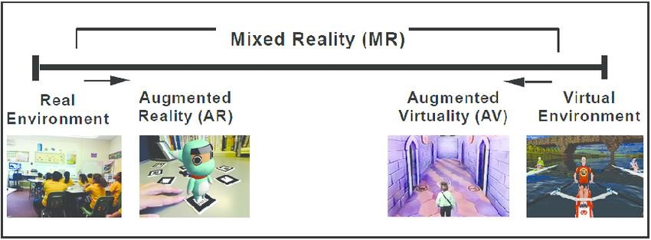
Figure 5.1 Paul Milgram's Reality-Virtuality (RV) Continuum
5.2.1. Virtual Reality (VR)
VR is fully immersive, which tricks your senses into thinking you’re in a different environment or world apart from the real world. Using a head-mounted display (HMD) or headset, you’ll experience a computer-generated world of imagery and sounds in which you can manipulate objects and move around using haptic controllers while tethered to a console or PC. It is also called a computer-simulated reality. It refers to computer technologies using reality headsets to generate realistic sounds, images and other sensations that replicate a real environment or create an imaginary world. Advanced VR environment will engage all five senses (taste, sight, smell, touch, sound), but it is important to say that this is not always possible (See Figure 5.2).
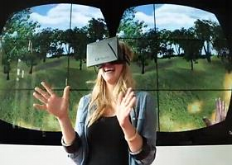
Using VR devices such as HTC Vive, Oculus Rift or Google Cardboard, users can be transported into a number of real-world and imagined environments.
The most advanced VR experiences even provide freedom of movement – users can move in a digital environment and hear sounds. Moreover, special hand controllers can be used to enhance VR
experiences. Figure 5.2 Example of Immersive Technology
Most VR headsets are connected to a computer (Oculus Rift) or a gaming console (PlayStation VR) but there are standalone devices (Google Cardboard is among the most popular) as well. Most standalone VR headsets work in combination with smartphones – you insert a smartphone, wear a headset, and immerse in the virtual reality (see Figure 5.3).
Figure 5.3 VR Case that Inserts a Smartphone
5.2.2. Augmented Reality (AR)
In augmented reality, users see and interact with the real world while digital content is added to it. If you own a modern smartphone, you can easily download an AR app and try this technology.
There’s a different way to experience augmented reality, though – with special AR headsets, such as Google Glass, where digital content is displayed on a tiny screen in front of a user’s eye.
AR adds digital elements to a live view often by using the camera on a smartphone. Examples of augmented reality experiences include Snapchat lenses and the game Pokemon Go. Augmented Reality (AR) is a live, direct or indirect view of a physical, real-world environment whose elements are augmented (or supplemented) by computer-generated sensory input such as sound, video, graphics or GPS data (see Figure 5.4).
Figure 5.4 Direct and Indirect Augmentation of Objects
5.2.3. Mixed Reality (MR)
Mixed Reality (MR), sometimes referred to as hybrid reality, is the merging of real and virtual worlds to produce new environments and visualizations where physical and digital objects co-exist and interact in real-time. It means placing new imagery within a real space in such a way that the new imagery is able to interact, to an extent, with what is real in the physical world we know (see Figure 5.5 and Figure 5.6).
For example, with MR, you can play a virtual video game, grab your real-world water bottle, and smack an imaginary character from the game with the bottle. Imagination and reality have never been so intermingled.
The key characteristic of MR is that the synthetic content and the real-world content are able to react to each other in real-time.
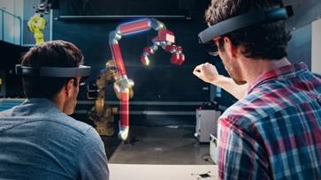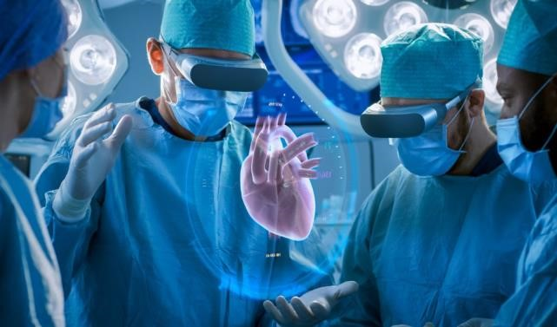
Figure 5.5 Mixed Reality in Engineering and Medicine
In mixed reality, you interact with and manipulate both physical and virtual items and environments, using next-generation sensing and imaging technologies. MR allows you to see and immerse yourself in the world around you even as you interact with a virtual environment using your own hands—all without ever removing your headset.
Figure 5.6 Mixed Reality in Entertainment
It provides the ability to have one foot (or hand) in the real world, and the other in an imaginary place, breaking down basic concepts between real and imaginary, offering an experience that can change the way you game and work today.
One of the most obvious differences among augmented reality, virtual reality, and mixed reality is the hardware requirements and also VR is content which is 100% digital and can be enjoyed in a fully immersive environment, AR overlays digital content on top of the real-world. and MR is a digital overlay that allows interactive virtual elements to integrate and interact with the real-world environment. Numerous augmented reality apps and games can run on almost every smartphone on the market.
On the other hand, virtual reality programs require specialized VR headsets, noise-canceling headphones, cameras to track room space and boundaries, and sometimes even motion capture technology. Some of the biggest names in VR tech today are the Oculus Rift, HTC Vive, and PlayStation VR. For the enjoyment of simple VR videos, there are affordable makeshift VR headsets like the Google Cardboard, which work by running a video in 360 modes on your smartphone and inserting the phone into the headset.
Mixed reality hardware is still emerging and hasn’t quite broken into the mainstream consumer market, most likely due to the price. The consumer releases of the Microsoft HoloLens and Magic Leap One retail for over $2000 USD, which is 3 to 4 times the cost of the PlayStation VR and HTC Vive VR headsets. However, mixed reality applications sometimes require exponentially more processing power and thus require more powerful hardware.
For example, the Microsoft HoloLens includes a built-in microphone array, binaural sound capabilities, a built-in camera for recording, a depth sensor, head-tracking cameras, and an inertial measurement unit which helps track your head movement. On top of the traditional CPU and GPU, Microsoft also created a Holographic Processing Unit to help track where the user is looking and understand command gestures.
5.3. The architecture of AR Systems
The first Augmented Reality Systems (ARS) were usually designed with a basis on three main blocks, as is illustrated in Figure 5.7: (1) Infrastructure Tracker Unit, (2) Processing Unit, and (3) Visual Unit. The Infrastructure Tracker Unit was responsible for collecting data from the real world, sending them to the Processing Unit, which mixed the virtual content with the real content and sent the result to the Video Out module of the Visual Unit. Some designs used a Video In, to acquire required data for the Infrastructure Tracker Unit.

Processing
Unit

Infrastr
ucture
Tracker Unit

Video In

Video Out

Positioning and
orientation data

Mix the
realities

Mixed
realities

Real world
visual data

Captured video for
computer vision and
image processing

Video Out with
the mixed worlds

Real world
data from
sensors

Visual
Content

Visual Unit

Figure 5.7 Augmented Reality Systems (ARS) standard architecture

The Visual Unit can be classified into two types of system, depending on the followed visualization technology:
- Video see-through: It uses a Head-Mounted Display (HMD) that employs a video-mixing and displays the merged images on a closed-view HMD.
- Optical see-through: It uses an HMD that employs optical combiners to merge the images within an open-view HMD.
HMDs are currently the dominant display technology in the AR field. However, they lack in several aspects, such as ergonomics, high prices and relatively low mobility due to their sizes and connectivity features. An additional problem involving HMD is the interaction with the real environment, which places virtual interactive zones to the user, making the collision with these zones hard due to the difficulty to interact with multiple points in different depths. Alternative approaches to developing ARS involve the use of monitors and tablets. Monitors are used as an option for indirect view since the user does not look directly into the mixed world. Tablets are used in direct view since the user points the camera to the scene and looks directly into the mixed world.
Both approaches still have difficulties in getting a collision.

5.4. Applications of AR Systems
Technology is ever-changing and ever-growing. One of the newest developing technologies is augmented reality (AR), which can be applied to many different disciplines such as education, medicine, entertainment, military, etc. Let us see some of its applications.
5.4.1. AR In education
Augmented reality allows flexibility in use that is attractive to education. AR technology can be utilized through a variety of mediums including desktops, mobile devices, and smartphones. The technology is portable and adaptable to a variety of scenarios. AR can be used to enhance content and instruction within the traditional classroom, supplement instruction in the special education classroom, extend content into the world outside the classroom, and be combined with other technologies to enrich their individual applications. More importantly, the following reasons for using augmented reality in education:
- Affordable learning materials - posters, digital illustrations, physical models, prototypes are very expensive and it’s impossible for schools to find enough money to purchase all the supplementary materials they would like to. Using AR technology allows for avoiding investments in physical materials. Besides, students can get access to learning materials and interact with them anytime.
- Interactive lessons - when AR technology is used in classrooms, students can view models on their own smartphones and get a better idea of the concepts they are studying. That increases engagements and reinforces the learning.
- Higher engagement - when teachers integrate augmented reality into their lectures, they attract the attention of their students and make lessons more effective. When students are interested, it is much easier to make them work more productively.
- Higher retention - using the AR app, students can get access to augmented models that represent any real objects from a famous monument or work of art to a molecule. Besides, students can get access to a website with specific information. When learning with AR technology, students use different senses and retain more knowledge for a long time.
- Boost intellectual curiosity - augmented reality makes students more excited about learning certain subjects. Modern students were born in a digital era so they will always be excited with innovative technologies that can help them learn new ideas and develop their critical thinking skills.
When using AR technology in the classroom, teachers can create an authentic learning environment for students with different learning styles.
5.4.2. AR In Medicine
Augmented reality is one of the current technologies changing all industries, including healthcare and medical education.
The purpose of any invention and technology is to simplify our life. Augmented reality has the potential to play a big role in improving the healthcare industry. Only a few years since the first implementations of augmented reality in medicine, it has already filled an important place in doctors’ and nurses’ routine, as well as patients’ lives.
This new technology is enhancing medicine and healthcare towards more safety and efficiency. For now, augmented reality has already made significant changes in the following medical areas:
- surgery (minimally invasive surgery);
- education of future doctors;
- diagnostics;
- AR tools may also aid to detect the signs of depression and other mental illnesses by reading from facial expressions, voice tones, and physical gestures.
In medicine, AR has the following applications:
  - Describing symptoms - Have you ever been in a situation when it was hard to describe to the doctor what was bothering you? It is a common problem for all us, the roots of which extend to overreacting and lack of knowledge. And what is most important, it impacts on finding out the accurate diagnosis. The first steps to find the solutions are already made.
To increase patients’ education, medical app AyeDecide is using augmented reality to show the simulation of the vision, harmed by the different diseases. It helps patients to understand their conditions and describe correctly their symptoms.
  - Nursing care - About 40% of the first intravenous injections fail, and this ratio is even higher in the case of children and elderly patients. The AccuVein uses augmented reality to cope with this negative statistic. A handheld scanner projects on the skin and shows the patients’ veins. It increases the successful finding of the vein from the first try in 3,5 times. That is why this invention got the greatest recognition among the general public and medical staff.
  - Surgery - In no sphere augmented reality does not have such practical application as in the medicine, especially in surgery, where it literally helps to save lives. Three dimensional reconstructions of organs or tumors will help surgeons become more efficient at surgery operations. For example, spinal surgery, as usually, is a long and difficult process. But with the use of AR, it can reduce the time, cut the risks and improve the results. The Israeli startup Augmedics had created an augmented reality headset for spine surgeons. This technology overlays a 3D model of the CT-scan on the spine, so, the surgeon gets some kind of “X-ray” vision.
  - Ultrasounds - Some time ago ultrasound made a small revolution in medicine. Today, it has another one chance to make the same with using augmented reality. Already a few AR software companies developed handy ultrasound scanner, which with the help of smart glasses works as a traditional one. It is hard to overestimate the usefulness of this technology. Especially when we talk about using it in the developing countries, in military medicine (on the battlefields) and even in the ambulance.
  - Diabetes management - In 2017, the number of people struggle with diabetes reached up to 425 million adults worldwide. And the amount of diagnosed people is increasing every year. In 2014, Google revealed the plans for creating a smart contact lens (Google
Contact Lens), in which the main function will be to measure the glucose levels in the tears. It will help people with this disease to live the life they used to, without permanent worries about sugar level in the blood.
  - Navigation - The using AR in navigation apps has already become a “traditional” way. By pointing your phone to the city landscape, you get the information about nearby objects of your interest (museums, hotels, shops, metro stations, etc.). The same way AR can be useful to provide information about the nearest hospitals. For example, the EHBO app helps to find the nearest to you AEDs (automated external defibrillators).
Generally, AR provides the following benefits to patients and healthcare workers:
- Reduce the risks associated with minimally invasive surgery.
- Better informed decisions about the right treatment and illness prevention.
- Make procedures more tolerable.
- Better aftercare
- Medical training and education.
- Assistance in medical procedures and routine tasks.
5.4.3. AR In Entertainment
Augmented reality can be used in various “entertainment” industries as entertainment covers quite a number of different industries – music, movies, live shows, games – and all of them can benefit from using augmented reality.
- AR in games - the AR games were praised for increasing physical activity in people – you actually have to move around to find your target, for example, Pokémon. At the same time, there are complaints that players could cause various incidents and accidents being too engrossed in the game. In any case, Pokémon GO has rightfully earned its popularity and opened the world of AR games to us.
- AR in music - music is not only about listening to favorite tracks and putting together playlists. When we like a piece, we often want to find out more about its background: the performers’ bios, the lyrics of the song, the making of the recording or the music video. Augmented reality can do all that and much more providing complete information on the track or its performer. Augmented reality can enhance live performances by illustrating the story told by a track or displaying the way it was created by the band.
- AR on TV - this may seem a bit far-fetched, as television already shows a virtual world, thus adding augmented reality will raise it to the second power. However, some experiments of fusing augmented reality on TV are already being made with the promise of future enhancements. One way of integrating augmented reality in television is adding supplementary information to what is going on the TV screen – such as match scores, betting options, and the like.
- AR in eSports - recently, the industry of eSports has been gaining popularity in all parts of the globe. Competitive online gaming has become as fascinating as real sports, and the technology is following it closely with new solutions and unusual implementations. Augmented reality turns eSports shows into interactive experiences allowing the watchers to become participants.
AR in the theater - in this sector, augmented reality can serve not only for entertainment purposes but also for the purposes of accessibility. The possibility to overlay virtual objects over the real environment can be used, for example, for subtitling in various theater shows. Now, many theaters use LED displays either to provide subtitles for translation or to assist hearing-impaired visitors. However, LED equipment is not available in each theater and even when it is, it can distract the viewers from the show.

Chapter 6: ETHICS AND PROFESSIONALISM OF EMERGING TECHNOLOGIES

Introduction
In the previous chapters, emerging technologies like big data, artificial intelligence, internet of things and augmented reality were discussed. After having a discussion on all of the above emerging technologies, it is time to study their connection with our ethical values as well as social values. In this chapter, the connection of emerging technologies with professional ethics, privacy, accountability, trust was discussed. Finally, the threats and challenges of emerging technologies will be explained.
After accomplishing this chapter, Students will be able to:
- Distinguish the link between ethics and technology.
- Understand general, professional and leadership ethical questions.
- Explain what digital privacy is, its components and why it is important.
- know the importance of accountability and trust in emerging technologies.
- Identify the threats and challenges we face in developing and utilizing emerging technologies.

6.1. Technology and ethics
The Internet boom has provided many benefits for society, allowing the creation of new tools and new ways for people to interact. As with many technological advances, however, the Internet has not been without negative aspects. For example, it has created new concerns about privacy, and it has been hampered by spam and viruses. Moreover, even as it serves as a medium for communication across the globe, it threatens to cut off people who lack access to it.
Technology can serve to promote or restrict human rights. The Information Society should foster the use of emerging technologies in such a way as to maximize the benefits that they provide while minimizing the harms. In many cases, this promotion may be less a matter of technological control than of oversight: establishing the proper legal or regulatory system to ensure that technology capable of abuse is not in fact abused and that the benefits of technology are shared among all.
Ethics is particularly important for the accountancy profession, with a code for professional ethics based on five basic principles – integrity, objectivity, competence and due care, confidentiality, and professional behavior. However, the emergence of new technologies raises some new challenges for the profession to address.
6.2. New ethical questions
The increasing use of big data, algorithmic decision-making, and artificial intelligence can enable more consistent, evidence-based and accurate judgments or decisions, often more quickly and efficiently. However, these strengths can potentially have a darker side too, throwing up questions around the ethical use of these fairly new technologies.
For example, outputs can be based on biased data, which could lead to discriminatory outcomes. Indeed, where systems learn from real-world data, there is a significant risk that those systems simply recreate the past and subsequently build in errors or systemic biases. Closely linked to discrimination is personalization, and the impact of tailoring decisions very specifically to individuals, based on preferences, activities and other features. While this can be beneficial for many, others can lose out, and outcomes can again seem unfair or unethical.
Additionally, questions are being asked regarding the interaction between computers and humans. How much reliance can we place on data and models, and what is the role of human judgment, as well as how do we ensure that we understand the decision-making process? Whatever the power of the machine, humans will still need to be involved, so that people can be held accountable, or explain the reasons behind a decision.

A central problem of the ethics of technology is that it tends to arrive too late. In many cases, ethical issues are only recognized when the technology is already on the market and problems arise during its widespread use. Ethics can then become a tool to clean up a mess that might have been avoidable. It is probably not contentious to say it would be desirable to have ethical input at the earlier stages of technology design and development. Indeed, there are ethical theories and approaches that explicitly aim at an early integration of ethics into the technology life cycle. One central problem of this type of approach is that the future is unknown. By definition, we do not know with certainty what will happen in the future and ethics that relies on future development needs to be able to answer the question of how it decides which technological developments to pursue. Ethics has traditionally not been well equipped to deal with issues of uncertainty and, in particular, future uncertainty.
6.2.1. General ethical principles
1. Contribute to society and to human well-being, acknowledging that all people are stakeholders in computing. 2. Avoid harm.
- Be honest and trustworthy.
- Be fair and take action not to discriminate
- Respect the work required to produce new ideas, inventions, creative works, and computing artifacts.
- Respect privacy.
- Honor confidentiality
6.2.2. Professional responsibilities.
- Strive to achieve high quality in both the processes and products of professional work.
- Maintain high standards of professional competence, conduct, and ethical practice.
- Know and respect existing rules pertaining to professional work.
- Accept and provide appropriate professional review.
- Give comprehensive and thorough evaluations of computer systems and their impacts, including analysis of possible risks.
- Perform work only in areas of competence.
- Foster public awareness and understanding of computing, related technologies, and their consequences.
- Access computing and communication resources only when authorized or when compelled by the public good.
- Design and implement systems that are robustly and usably secure.
6.2.3. Professional leadership principles.
- Ensure that the public good is the central concern during all professional computing work.
- Articulate, encourage acceptance of and evaluate fulfillment of social responsibilities by members of the organization or group.
- Manage personnel and resources to enhance the quality of working life.
- Articulate, apply, and support policies and processes that reflect the principles of the Code.
- Create opportunities for members of the organization or group to grow as professionals.
- Use care when modifying or retiring systems. Interface changes, the removal of features, and even software updates have an impact on the productivity of users and the quality of their work.
- Recognize and take special care of systems that become integrated into the infrastructure of society.

6.3. Digital privacy
Digital Privacy is the protection of personally identifiable or business identifiable information that is collected from respondents through information collection activities or from other sources.
It is a collective definition that encompasses three sub-related categories; information privacy, communication privacy, and individual privacy It is often used in contexts that promote advocacy on behalf of individual and consumer privacy rights in digital spheres, and is typically used in opposition to the business practices of many e-marketers/businesses/companies to collect and use such information and data.
6.3.1. Information Privacy
In the context of digital privacy, information privacy is the notion that individuals should have the freedom, or right, to determine how their digital information, mainly that pertaining to personally identifiable information, is collected and used. Every country has various laws that dictate how information may be collected and used by companies. Some of those laws are written to give agency to the preferences of individuals/consumers in how their data is used. In other places, like in the United States, privacy law is argued by some to be less developed in this regard, For example, some legislation, or lack of, allows companies to self-regulate their collection and dissemination practices of consumer information.
6.3.2. Communication Privacy
In the context of digital privacy, communication privacy is the notion that individuals should have the freedom, or right, to communicate information digitally with the expectation that their communications are secure; meaning that messages and communications will only be accessible to the sender's original intended recipient. However, communications can be intercepted or delivered to other recipients without the sender's knowledge, in a multitude of ways. Communications can be intercepted directly through various hacking methods; this is expanded upon further below. Communications can also be delivered to recipients unbeknownst to the sender due to false assumptions made regarding the platform or medium which was used to send information. An example of this is a failure to read a company's privacy policy regarding communications on their platform could lead one to assume their communication is protected when it is in fact not. Additionally, companies frequently have been known to lack transparency in how they use information, this can be both intentional and unintentional. Discussion of communication privacy necessarily requires consideration of technological methods of protecting information/communication in digital mediums, the effectiveness, and ineffectiveness of such methods/systems, and the development/advancement of new and current technologies.
6.3.3. Individual Privacy

In the context of digital privacy, individual privacy is the notion that individuals have a right to exist freely on the internet, in that they can choose what types of information they are exposed to, and more importantly that unwanted information should not interrupt them An example of a digital breach of individual privacy would be an internet user receiving unwanted ads and emails/spam, or a computer virus that forces the user to take actions they otherwise wouldn't. In such cases the individual, during that moment, doesn't exist digitally without interruption from unwanted information; thus, their individual privacy has been infringed upon.
6.3.4. Some digital privacy principles
- Data Minimization: collect the minimal amount of information necessary from individuals and businesses consistent with the Department’s mission and legal requirements.
- Transparency: Notice covering the purpose of the collection and use of identifiable information will be provided in a clear manner. Information collected will not be used for any other purpose unless authorized or mandated by law.
- Accuracy: Information collected will be maintained in a sufficiently accurate, timely, and complete manner to ensure that the interests of the individuals and businesses are protected.
- Security: Adequate physical and IT security measures will be implemented to ensure that the collection, use, and maintenance of identifiable information are properly safeguarded and the information is promptly destroyed in accordance with approved records control schedules.

6.4. Accountability and trust
When emerging technology creates far-reaching and rapid change, it can also bring new risks. Understanding and mitigating them will help to build confidence. Often legal and regulatory frameworks haven’t kept pace with digital transformation, and organizations are seeking guidance.
This challenge is exacerbated by the speed at which technological change is occurring and the breadth of its adoption – which is introducing new risks that demand new responses.
Emerging technologies can provide improved accuracy, better quality and cost efficiencies for businesses in every sector. They can enhance trust in the organization’s operations and financial processes, which is crucial for sustainable success. But this can produce a paradox: the very solutions that can be used to better manage risk, increase transparency and build confidence are often themselves the source of new risks, which may go unnoticed.
There’s a danger that the use of technology will degrade people’s willingness to judge and intervene because they feel that they are less personally connected to consumers and consumer outcomes – the logic of the machine has taken over from individual responsibility.
The obligation of an individual or organization to account for its activities, accept responsibility for them, and to disclose the results in a transparent manner. It also includes the responsibility for money or other entrusted property.

6.5. Treats and challenges
6.5.1. Ethical and regulatory challenges
With Technology moving at a fast pace it is always been a challenge for Security. As security professionals, we need to keep pace with ever-changing technology and be aware of the AI, IoT, Big Data, Machine Learning, etc. It is no more Guards, guns & gates it is more than that & we need to play a major role for a security professional to support business or rather we should be able to understand the language of business and talk to the leaders in their language. With Growing needs Cyber & Data Security is getting prominence that requires security practitioners to focus on the business need for securing data, understanding security and risk from a business perspective by extensively interacting with the business community in understanding their requirements or what they want.

Emerging technologies are already impacting how we live and work. They're also changing how we approach, plan, and integrate security operations. Certainly, we are living in an era where innovation, agility, and imagination are all essential in order to keep pace with the exponential technological transformation taking place. For security, both physical and cyber, the equation is the same catalyzing many new potential applications for emerging technologies. Emerging technologies are making an impact include:
- Counter-terrorism and law enforcement informatics via predictive analytics and artificial intelligence.
- Real-time horizon scanning and data mining for threats and information sharing
- Automated cybersecurity and information assurance
- Enhanced Surveillance (chemical and bio-detection sensors, cameras, drones, facial recognition, license plate readers)
- Simulation and augmented reality technologies for training and modeling
- Safety and security equipment (including bullet and bomb proof) made with lighter and stronger materials
- Advanced forensics enabled by enhanced computing capabilities (including future quantum computing)
- Situational awareness capabilities via GPS for disaster response and crisis response scenarios
- Biometrics: assured identity security screening solutions by bio-signature: (every aspect of your physiology can be used as a bio-signature. Measure unique heart/pulse rates, electrocardiogram sensor, blood oximetry, skin temperature)
- Robotic Policing (already happening in Dubai!)

6.5.1.1. Challenges in using Artificial Intelligence
AI is only as good as the data it is exposed to, which is where certain challenges may present themselves. How a business teaches and develops its AI will be the major factor in its usefulness. Humans could be the weak link here, as people are unlikely to want to input masses of data into a system.
Another dilemma that comes along with AI is its potential to replace human workers. As machines become more “intelligent” they could begin to replace experts in higher-level jobs. Alternatively, AI also has the potential to take the burden of laborious and time-consuming tasks from these people, freeing up their time and brainpower for other things e.g. doctors using diagnostic AI to help them diagnose patients will analyze the data presented by the AI and make the ultimate decision. Managing the challenges posed by AI will require careful planning to ensure that the full benefits are realized and risks are mitigated.
6.5.1.2. Challenges in using Robotics in manufacturing
With automation and robotics moving from production lines out into other areas of work and business, the potential for humans losing jobs is great here too. As automation technologies become more advanced, there will be a greater capability for automation to take over more and more complex jobs. As robots learn to teach each other and themselves, there is the potential for much greater productivity but this also raises ethical and cybersecurity concerns.

6.5.1.3. Challenges in using the Internet of Things
As more and more connected devices (such as smartwatches and fitness trackers) join the Internet of Things (IoT) the amount of data being generated is increasing. Companies will have to plan carefully how this will affect the customer-facing application and how to best utilize the masses of data being produced. There are also severe security implications of mass connectivity that need to be addressed.
6.5.1.4. Challenges in Big Data
Almost all the technologies mentioned above have some relation to Big Data. The huge amount of data being generated on a daily basis has the potential to provide businesses with better insight into their customers as well as their own business operations.
Although data can be incredibly useful for spotting trends and analyzing impacts, surfacing all this data to humans in a way that they can understand can be challenging. AI will play a role here.
6.5.2. Treats
New and emerging technologies pose significant opportunities for businesses if they utilize them well and understand their true value early on. They also pose risks and questions not only to business but to society as a whole. Planning for how to deal with these emerging technologies and where value can be derived while assessing potential risks before they become a fully-fledged reality is essential for businesses that want to thrive in the world of AI, Big Data and IoT.
Some risks of emerging technology are:
- Driverless car: while a compelling option for future fleer cars, companies could crash and burn from claims related to bodily injury and property damage.
- Wearables: Google glass, Fitbit and other wearables can expose companies to the invasion of privacy claims that may not be covered by general liability or personal injury claims that weren’t foreseen.
- Drones: Turbulence is in the offing for manufacturers and organizations that fail to protect themselves for property damage and bodily injury, as well as errors and omissions.
- Internet of things: The proliferation of sensors and cross-platform integration creates potential exposure from privacy invasion, bodily injury and property damage that may connect an organization to huge liabilities.

