CHAPTER FOUR
MOTIVATION CONCEPTS AND THEIR APPLICATIONS
1.1 What is motivation?
It is essential to increase overall efficiency of human beings to improve performance of an organization. While machines, processes, technology of high order can be made available to the individuals, but high productivity can only be achieved if workers are highly skilled and adequately motivated. Motivation perhaps is a single most important factor of the study of organizational behavior that concerns each and every executive today.
Definition:
Motivation: Scot defined motivation as “a process of stimulating people to action to accomplish desired goals”.
Mc Farland has defined “motivation as the way in which urges, drives, desires, aspirations, strivings needs direct, control or explain the behavior of human beings”.
Memoria: “A willingness to expand energy to achieve a goal. It is a force that activates dormant energies and sets in motion the action of the people. It is the function that kindles a burning passion for action among the human beings of an organization”.
Motivation is defined as “inner burning passion caused by need, wants and desire which drives an individual to exert his physical and mental energy to achieve desired objectives”.
4.2. Characteristics of Motivations
- Motivation is a psychological phenomenon. It is the inner desire of an individual to accomplish something more. The very deficiency forces him to undertake certain amount of work. More is the individual motivated better the performance and organization relations.
- Motivation is a continuous process. Since need is a continuous phenomenon if one need is satisfied the other need emerges and so does individual propels to work and thus the continuous chain is created.
- Motivation is caused due to anticipated perceived value from an action. Perceived value is the probability or the expectancy. Therefore motivation=valance (value) × expectancy.
- There are unsatisfied needs. A person remains disturbed till they are satisfied. This disturbance or tension causes disequilibria in human behavior. More the motivation level the higher will be efforts to get over the tension and in the process job accomplishment would take place.
- Individual is motivated by positive motivation. It refers to incentives offered by the organization to achieve efficiency. Incentive can be monetary like increase in pay, allowances, and payment of bonus. Payment for additional or overtime work. It can be non-monetary like issuing of certificates for excellence, awards, recognition, status, job enrichment, competitions, and the like. Monetary rewards prevent individuals from getting de-motivated or they do not motivate so to say. However non-monetary awards motivates individual as it is related to the inner/psychological aspects.
4.3. Importance of Motivation
(A) High level of performance: It is the duty of every manager to ensure that the employees have a high degree of motivation. He should offer monetary and non-monetary incentives. Highly motivated workers would be regular for work, and have a sense of belonging for the organization. Quality of product will be improved, wastage will be minimized and there will be increase in productivity, and performance level will be high.
In most instances, employee performance is determined by three things: motivation (the desire to do the job), ability (the capability to do the job), and the work environment (the tools, materials and information needed to do the job).
Ability × Motivation × Environmental Conditions = Performance

(B) Low employee turnover and absenteeism. Employee turnover and absenteeism is caused due to low level of motivation on the part of managers. When dissatisfaction is increased employees do not enjoy the work assigned to them. Therefore there is a tendency of absenteeism. The workers hunt for an alternative job and leave the organization whenever they get an opportunity. High level of absenteeism causes low level of production, wastages, poor quality and disruption in production schedules. Increased turnover is disastrous for any organization as it puts strain on financial position of the organization due to additional recruitment, selection, training and development. Motivation is therefore a very important management tool to achieve organizational excellence.
(C) Organizational image: Employees are the mirrors of any organization. Managers must lay down high performance standards coupled with high monetary and non-monetary rewards. Training & development programs should be regularly organized and employee skill improved. It will have a positive impact on the employees and the image of the organization will be improved. High organizational image will contribute towards brand image of the product and services of the organization.
4.4. Early Theories of Motivation
- Hierarchy of Needs Theory.
A humanistic psychologist, teacher and practitioner developed a need-based theory of motivation. Maslow’s theory is now considered central to understanding human motivations and behavior. In 1943, in an article for psychological Review “A theory of human motivation “Maslow” identified and analyzed five basic needs which he believed underlay all human behavior.
These needs relate to: Self –Actualization needs, esteem needs, social needs, safety needs and Physiological needs

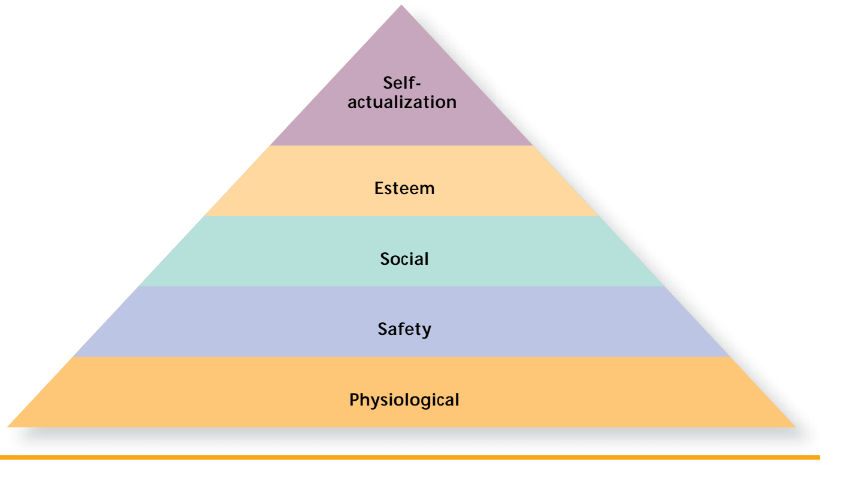 Figure 4.1: Abraham Maslow’s hierarchy of human needs.
  - Physiological Needs: - Basic needs such as food, water, clothing, shelter, sleep etc. these are primary needs for sustaining human life. Until these needs are satisfied to the extents necessary to sustain life these needs remain the motivating force.
  - Safety needs: - Includes security and protection from physical and emotional harm.
  - Social needs: - need for acceptance, love, friend ship, social interaction
  - Esteem Needs: - This is the need to attain recognition, achievement, power, status, autonomy and prestige.
  - Self-actualization needs: This last need is the need to develop fully and realize one’s capacities and potentials to the fullest extent possible. At this level the person seeks challenging work assignments.
Maslow’s theory is based on the following assumptions:
- Only unsatisfied need can influence behavior, a satisfied need is not a motivator,
- A person’s are arranged in a priority order of importance
- A Person will at least minimally satisfy each level of need before feeling the need at the next level.
- Mc GREGOR’S THEORY X AND THEORY Y
Assumption about human nature that underlines Theory X and theory Y

Theory X (negative view about employees) | Theory Y (positive view about employees)
- Employees dislike work if possible avoids.  - Most people have little desire for responsibility and prefer to be directed.  - Most people have little capacity for creativity in solving organizational problems.  - Motivation occurs only at the physiological and safety need levels.  - Most people must be closely controlled and often forced to do the work. | - Employees love work as play or rest.  - accept and seek responsibility  - They are creative in solving organizational problems  - Motivation occurs at social, esteem and self-actualization need levels.  - People can be self-directed and self-controlled.

- Hygien Theory of Motivation
This theory suggested that factors that are associated with dissatisfaction are different from those factors, which create satisfaction. These two factors are:
- Hygiene factors (Maintenance/ dissatisfies)
- Motivation factors (Motivators/satisfiers)
A. Hygiene/maintenance factors
Some conditions of a job operate primarily to dissatisfy employees when they (the conditions) are not present. However, the presence of this condition doesn’t build strong motivation. They are necessary to maintain a reasonable level of satisfaction (to minimize dissatisfaction). These factors are; working conditions, supervision, company policy, relationship with supervisor, relationship with subordinates, salary, status and security etc.
B. Motivators (Motivating factors)
Some job conditions build high level of motivation and job satisfaction. Herzberg described six of these motivational factors or satisfiers. Achievement, recognition, works itself, responsibility, advancement and growth.
Hygiene factors
- Working condition
- Salary
- Company policy
- R/ship wit supervisors
- R/ship with subordinates
- Status
- Security
- Supervision
Motivating factors
- Achievement
- Recognition
- Work itself
- Responsibility
- Advancement
- Growth

4.5. Contemporary theories of motivation
- ERG Theory
ERG theory is the modification of the need hierarchy theory that proposes three categories of needs:
- Existence needs-concerned with providing our basic material existence requirements for physical well being
- Relatedness needs-desire for maintaining satisfactory relationships with others
- Growth needs-focus on the development of human potential and the desire for personal growth and increased competence. It is intrinsic desire for personal development.
The ERG model theory is less rigid than Maslow’s need hierarchy, That is, Maslow’s hierarchy of need theory arranges human needs in to a priority order of importance. Satisfaction of any need activates the need at the next higher level, and people are presumed to move step by step up the hierarchy.
But Alderfer’s ERG theory, like Maslow, argues that satisfied lower-order needs leads to the desire to satisfy higher-order needs. The theory reduced the five needs in to three and allowed for more than one need to be activated at a time.
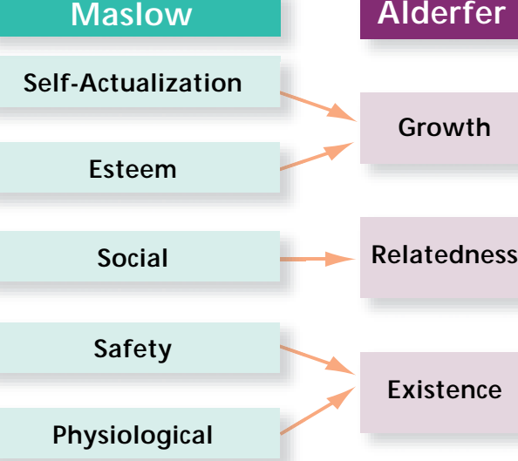

Relationship of Maslow and Alderfer ERG theory
- McClelland’s Theory of Needs
Peoples are motivated by three needs:
- Achievement or the desire to solve problems and leading complex task
- Power or the desire to control others or have influence over them
- Affiliation-the desire for friend ship, cooperation and close interpersonal relationships.
Achievement relates to individual performance, power and affiliation on the other hand, involve interpersonal relationships.

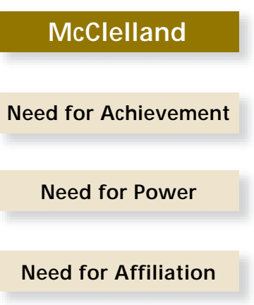

- Goal Setting Theory
Shows that intentions to work toward a goal are a major source of work motivation. A goal is “what an individual is trying to accomplish; it is the object or aim of an action.” Goals tell an employee what needs to be done and how much effort will need to be expended.
Goal-setting theory suggests that intentions to work toward a goal are a major
source of work motivation.
- Equity Theory
Equity theory focuses on individual’s perceptions of how fairly they are treated compared with others.
According to equity theory, if employees perceive their compensation is equal to what others receive for similar contributions, they will believe that their treatment fair and equitable. Employees evaluate equity by a ratio of inputs to outcomes. Inputs to a job include education, experience and efforts and ability /competence. Out comes from a job include pay, recognition, benefits, and promotions. The input to outcome ratio may be compared to another person in the work group or to a perceived group average. A state of equity exists whenever the ratio of one person’s out comes to the input. That is, managers allocate rewards, individuals make equity comparison, and job satisfaction and performance are affected.
Individuals reward’s compared other’s rewards
Individual inputs other’s inputs
In equity occurs when the input / outcome ratios are out of balance, such as when a person with a high level education or experience receives the same a salary as a new, less educated employee.
The implication of equity theory for managers is that employees indeed evaluate the perceived equity of their rewards compared to others. An increase in salary or a promotion will not have motivational effect if it is perceived inequitable relative to that of other employees.

- Expectancy Theory
According to these models, Motivation is strongly determined by an individual’s perception/expectation that a certain type of behavior will lead to a certain type of outcome and his personal preference for that type of outcome.
The keys to the expectancy theory are the expectancies for the relation among Effort, Performance and outcomes or reward with the value of the outcomes or reward to the individual.
Expectancy theory says that an employee will be motivated to exert a high level of effort when
he or she believes (1) that the effort will lead to good performance; (2) that
good performance will lead to organizational rewards, such as a bonus, a salary
increase, or a promotion; and (3) that the rewards will satisfy his or her personal goals.
A. Expectancy (Effort performance relationship) expectancy involves whether putting effort in to a task will lead to high performance. For this expectancy to be high individual must have the ability to perform.
B. Instrumentality (Performance outcome relationship) involves an individual’s belief on whether successful performance will leads to the desired reward. This concerns the belief that the higher performance will truly lead to reward. If the P - O expectancy is high, the individual will be more highly motivated. If the expectancy of P -O is low performance will not produce the desired outcome and motivation.
C. Valance - is the value of the outcomes, or attraction for outcomes for the individual. If employees don’t value the outcomes that are available from high effort and good performance, motivation will be low. Likewise, if outcomes have high value, motivation will be higher.

MF= Expectancy x Instrumentality x Valance

Instrumentality
Perceived probability that Good performance will lead to desired outcomes /Rewards
Expectancy
Perceived probability that effort will lead to Good performance
Motivational Force
Force directing Specific Behavioral Alternatives
Valance
Value of expected rewards to the individual

= X X

4.6. Implication of motivation for Managers
- In Order to Motivate Employees
  - Recognize individual differences.
  - Allow employees to participate in decisions that affect them.
  - Link rewards to performance.
  - Check the system for equity.

4.7 .Managerial approaches for improving motivation
Various groups provide specific challenges in terms of motivation. Some of them are explained below.

1. Motivating Temporary Workers: Temporary workers may be motivated in the following ways:
      - When there is a system whereby permanent employees are selected from a pool of temporary employees, the latter will often work hard in hopes of becoming permanent.
      - The ability of a temporary employee to find a new job is dependent on his or her skills.
- Therefore, temporary employees may be provided with the opportunity for training.
c) When temporary employees work alongside permanent employees who earn more pay for doing the same job, they are likely to be de-motivated.
- Separating such employees might help to lessen this problem.
2. Motivating the Diversified Workforce: Not everyone is motivated by money. Not everyone wants a challenging job.
- The needs of women, physically disabled and other diverse groups are not the same.
- If you are going to maximize your employees’ motivation, you have got to understand and respond to this diversity. This can be done in the following ways:
a) We should be flexible and design work schedules, compensation plans, benefits, and physical work settings, etc. to reflect the employees’ varied needs.
b) Allowing employees who are going for further training to colleges to vary their work schedule.
c) Offering employees facilities like child care, flexible work hours and job sharing for employees with family responsibilities.

